Project on

Design and Development of Web based Application for Educational Purpose

Submitted for partial fulfilment of award of

### **BACHELOR OF TECHNOLOGY**

degree

In

Electronics & Communication Engineering

By

1. Aditya Dhunna (1900300310009)
2. Aryan Bisht (1900300310020)
3. Khushi Srivastava (1900300310046)

Under the supervision of



**INDERPRASTHA ENGINEERING COLLEGE, GHAZIABAD,**

**Dr. A P J ABDUL KALAM TECHNICAL UNIVERSITY**

**LUCKNOW**

**JUNE 2023**

**Certificate**

### This is to certify that this group has carried out the project work presented in this report entitled **Designing and Development of Web based application for educational purposes** for the award of **Bachelor of Technology** from Inderprastha Engineering College, Ghaziabad, under my supervision. The report embodies results of original work and studies carried out by students themselves and the contents of the report do not form the basis for the award of any other degree to the candidate or to anybody else.

Mentor Name: Dr. Swati Vaid

Designation:

Date:

#### **Acknowledgement**

We take this opportunity to thank our teachers and friends who helped us throughout the project.

We would like to thank my guide for the project Dr. Swati Vaid, Asst Professor, Department of Electronics & Communication Engineering, Inderprastha Engineering College for her valuable advice and time during development of the project.

We would also like to thank all faculty and staff members of Electronics & Communication Engineering for their constant support during the development of the project.

Name: Name:

Roll No. Roll No.

Signature Signature

Name:

Roll No.

Signature

**Declaration**

*I hereby declare that this submission is my own work and that, to the best of my knowledge and belief, it contains no material previously published or written by another person nor material which to a substantial extent has been accepted for the award of any other degree or diploma of the university or other institute of higher learning, except where due acknowledgment has been made in the text.*

*Signature:*

*Name:*

*Signature:*

*Name:*

*Signature:*

*Name:*

**Abstract**

This project presents the design & development of web-based application for education purpose. The website is designed using figma & developed using MERN (MongoDB, ExpressJS,NodeJS & ReactJS). The design flow of website is along with basic layout is shown in the paper with the help of application. This application has the following features: - easy communication, focus & attempt to boost productivity, provides lively interaction. It aids in developinga skill-oriented community through a dedicated job portal, mentorship courses & sessions. The main purpose of this project thesis is to present the design of an application to bridge the gap the between colleges’ education and company as well as company requirements. The overall development of this application will aid students to grow their skills and get prepared for the job.

### **Table of Contents**

|  |  |
| --- | --- |
| **TOPIC** | **PAGE NUMBER** |
| 1. Introduction and Literature Survey | 7-8 |
| i. Introduction | 7 |
| ii. Literature Survey | 7 |
| 2. Software Used | 8 |
| 3. User Interfaces (UI) of the developed application | 9-17 |
| i. Structure of all the tabs present in the application. | 9 |
| ii. Sign In Page | 10 |
| iii. Sign Up Page | 11 |
| iv. Dashboard Page | 12 |
| v. Chat Page | 13 |
| vi. Create Group Page | 14 |
| vii. Notification Page | 15 |
| viii. Profile Modal Page | 16 |
| ix. Job Portal Page | 17 |
| 4. Conclusion & Future Scope | 18 |
| i. Conclusion | 18 |
| ii. Future Scope | 18 |
| 5. References | 19 |
| 6. Appendix | 20-42 |

### **List of Figure**

|  |  |
| --- | --- |
| **Figure** | **PAGE NUMBER** |
| 1. Fig 1: Workflow of the Application | 11 |
| 2. Fig 2: Sign-In Page | 12 |
| 3. Fig 3: Sign-Up Page | 13 |
| 4. Fig 4: Dashboard Page | 14 |
| 5. Fig 5: Chat Page | 15 |
| 6. Create Group Page | 11 |
| 7. Notification Page | 12 |
| 8. Profile Modal Page | 13 |
| 9. Job Portal Page | 14 |
| 5. References | 18 |
| 6. Appendix | 18 |
|  | 18 |
|  | 19 |
|  | 22-44 |

|  |
| --- |
| **Chapter 1. INTRODUCTION**  **INTRODUCTION:**  Today, India’s Education technology (EdTech) industry is the second biggest in the world and it’s only rising. The industry is set to touch $3.2 billion by 2022. Indian youth is also driven towards the use of EdTech applications for not only enhancing their knowledge skills but also to plan for their future career development. In today’s world there is a huge gap between the education system and industries. The things taught by education institute are very much outdated and doesn’t match the requirements of industries. Apart from this there is a huge shortage of skill development courses, in market the skill development courses which are available is mostly related to coding side only there are hardly any course for other skills.  The objective of this application is to build a skill-oriented community and introduce a platform for students wherein they can interact with people of similar interest & skills. This way the students can stay connected & updated regarding their skills. It is an initiative for collective growth which shall help students in long run.  Some key features of the application proposed in this paper are as follows: -   * Easy Communication. * Focus and attempt to boost productivity. * Provides lively interactions. * Develop the community. * Dedicated Job Portal * Mentorship Courses * Sessions   **LITERATURE SURVEY**:  The literature available for design & development of web-based application are: -  In [1], AGILMAT is a web application designed to help students learn Mathematics, with focus on high-school algebra and calculus drills. A modular and extensible architecture and a wizard-based configuration interface decoupled from the system core are major design features of AGILMAT.  In [2], Recent developments in Web technologies and AI techniques to support efforts in making the Web more intelligent and provide higher-level services to its users have opened the door to building the Sematic Web. That fact has several important implications for Web-based education has become a very important branch of education technology.  In [3], Allowing students to use technology in the classroom has been increasingly more popular as technology advances and becomes more ubiquitous. However, many educators wrestle several aspects of edtech, including, how to start using edtech (Caukin, 2018), when to use edtech  (National Education Technology Plan [NETP], 2017), how to incorporate it without creating more distractions for students (Thomas, 2019), and ways that edtech can move students towards higher levels of thinking (Caukin & Trail, 2019)  **CHAPTER 2. SOFTWARE USED**  For the development of a web based ed-tech application tech stack used is MERN (MongoDB, ExpressJS, ReactJS & NodeJS) Stack. MERN stack is a JavaScript based framework.  **Front-End: -**  The front end of this website is designed using Figma & the development of front-end functionality is developed using ReactJS & CSS.   * Figma: -   Figma is used to design the user interface & user experience of the application.   * ReactJS: -   The ReactJS framework is an open-source JavaScript framework and library developed by Facebook. It's used for building interactive user interfaces and web applications quickly and efficiently with significantly less code than you would with vanilla JavaScript.  **Back-End: -**  The database used for this website is MongoDB, & ExpressJS which is a NodeJS framework is used to connect MongoDB with the client side.   * ExpressJS: -   Express is a node js web application framework that provides broad features for building web and mobile applications. It is used to build a single page, multipage, and hybrid web application.   * NodeJS: -   Node is an open-source, cross-platform JavaScript runtime environment and library for running web applications outside the client's browser   * MongoDB: -   MongoDB is a document database used to build highly available and scalable internet applications.   * Bcrypt: -   It is a NodeJS framework which used for data encryption. It uses Blowfish encryption algorithm for encryption purposes.  **CHAPTER 3. USER INTERFACES (UI) OF THE DEVELOPED APPLICATION**  **STRUCTURE OF ALL THE TABS PRESENT IN THE APPLICATION**    Fig 1: Work Flow of the Application  The figure 1, displays the workflow of the application. The user lands on the Sign In page. The user is expected to enter the valid credentials if he is an existing user. If not, the user can move on to the Sign-Up page wherein he can create a profile. The user moves back to the Sign In page and enters the new credentials. Post Sign In, the user lands on the dashboard. On the Dashboard page, he is introduced to four options to choose from which are Mentorship, Chat, Jobs, Courses.  On opening the chat page, user interacts with different functionalities. The functionalities allow user to chat, search for other profiles, create and engage in group chats. There is no limit to adding members in a group. On the Jobs portal, the user interacts with all the notices from the training and placement department regarding jobs and placements.   1. **Sign In Page**     Fig 2: Sign-In Page  Front-End:  Fig 2 displays the Sign-In Page of the application. For designing the page, Figma has been used. For development, React.js has been used along with material UI which is a component based library as well as CSS for styling purposes. Textfield has been used for Input CTA which is a component of material UI. Credentials like email and password which are entered by the user have been created by this material UI. For Login and Show Button CTAs, the HTML button component has been used. On-Click event handler is used with different functions. “Show” function has been used to display the hash password in normal readable text. “Login” button will trigger the login functionality which will redirect the user to the dashboard.  Back-End:  For back-end, 2 variables have been used one of which stores the email address and the other stores the password of the user. Bcrypt has been used to encrypt the password. JWT token is used for authentication purposes.   1. **Sign-Up Page:**     Fig 3: Sign Up Page  Front-End:  Fig 3 displays the Sign-Up Page of the application. For designing the page, Figma has been used. For development, React.js has been used along with material UI which is a component based library as well as CSS for styling purposes. Textfield has been used for Input CTA which is a component of material UI. Credentials like name, email, password and confirm password which are entered by the user have been created by this material UI. For Login and Show Button CTAs, the HTML button component has been used. On-Click event handler is used with different functions. “Show” function has been used to display the hash password in normal readable text. “Sign-Up” button will trigger the sign-up functionality which will redirect the user to the dashboard. “Browse” function helps user select his/her profile picture.  Back-End:  For back-end, 6 variables have been which store the email address, the password of the user and confirm password. Bcrypt has been used to encrypt the password. JWT token is used for authentication purposes. Multer has been used to store an image in the database.   1. **Talk-A-Tive Dashboard Page**     Fig 4: Dashboard Page  Fr Front-End:  Fb Fig 4 displays the Dashboard Page of the application. 6 different “div” tags have been used from HTML which includes 2 parents div’s inside which 2 child div’s have been used to further wrap the components. In the parent div’s, flexbox has been used to align both the child div’s in a row. To align the component in the centre, ‘justify content’ and ‘align centre’ are used which are properties of flexbox. Link tag has been used from react-router-dom to redirect the user to the specific page as chosen by the user.   1. **Chat Page:**     **f**  Fig 5: Chat Page  Front-End:  Fig 5 displays the Chat Page of the application. A parent div has been used which further includes 2 child div’s. One child div is used to create header and the other has 2 more further div’s inside it. Using flexbox, they’ve been aligned in a row and the width given is 30% and 70%.  Back-end:  In a chat application, messages need to be delivered in real time. To achieve this, you would typically use a web socket protocol such as [Socket.IO](http://socket.io/) to establish a bidirectional communication channel between the client and server. To keep track of users and their messages, you would need to design and implement a database schema using MongoDB. You would need to create RESTful API endpoints that allow the front-end to communicate with the back end. These endpoints would handle tasks such as sending messages, retrieving message history, and updating user information.   1. **Create Group Page**     G Fig 6: Create Group Page  Fr Front-End:  Fig 6 displays the Create Group Project of the application. A material UI component called “Modal” has been used to create this Create Group Chat modal. Two input fields are used so that user can enter the Group Name and add the members in the group. “Button” has been used to create a “Create Chat” functionality to create a group for multiple users to chat on the same page. To display the added members of the group, multiple “div’s” with render functions are used.  Back-End:  A space will be created in the database and all the chats of the group will be saved in that \ space along with all the members of the group.     1. **Notification Page**     Fig 7: Notification Page  Front-End:  Fig 7 displays the Notification page of the application. This UI displays the notification functionality of the web-app. A notification box opens from the bell icon where all the notifications are displayed.  Back-End:  A. API has been created which provides the data required to display all the notifications.   1. **Profile Modal Page**   Fig 8: Profile Modal Page  Front-End:  Fig 8 displays the Profile Modal Page of the application. To create this page, axios is used to fetch the data from back-end. H1 and H4 tags are used to display the name and email. For profile picture, div tag is used. For the circular shape of the profile picture icon, border-radius is used.     1. **Job Portal Page**     Fig 9: Job Portal Page  Front-End:  Fig 9 displays the Job Portal Page of the application. “Table” component from material UI is used to create a table which displays all the notices regarding jobs and placements. To fetch the data, “axios” has been used. An on click button is applied on the view button which fetches the data from the backend. Hence, view button opens up the notice.  Back-End:  All the notices are stored here in the database. Multer is used to store files and mongodb collection. |

|  |
| --- |
|  |

**CHAPTER 4: CONCLUSION & FUTURE SCOPE**

**CONCLUSION:**

The design of web based ed – tech application is presented here to bridge the gap between people of interest in similar domain.​It is a skill-oriented application unlike other applications which provides features like: ​Chatting​, Online Courses, Mentorship​, Job portal​.

**FUTURE SCOPE:**

* Night mode enabled: - This feature allows the users to switch to a darker colour scheme on their device during the night-time hours. Dark mode reduces the strain on the eyes and also helps conserve battery life on some devices.
* Video calling: - With video calling, users can make high-quality audio and video calls with other users in real-time. This feature is useful for staying in touch with friends, family, or colleagues who are physically distant.
* Audio / Voice calling: - Audio calling, or voice calling, allows users to make phone calls over the internet instead of using traditional cellular networks. This feature is particularly useful for international calls as it eliminates long-distance charges.
* Broadcasting of messages: - This feature enables users to send a message to multiple recipients at once. It's useful for sending announcements or updates to a large group of people all at once.
* UPI payments: - UPI (Unified Payments Interface) is a payment system developed by the National Payments Corporation of India that enables users to easily transfer money between bank accounts. This feature allows users to make payments through the app quickly and securely.
* Live stream: - With live streaming, users can broadcast themselves live to an audience. This feature is popular for online events, webinars, or entertainment
* Mentorship: - This feature allows users to connect with mentors who can provide guidance, support, and advice on various topics. Mentors could be experts in a particular field or simply someone with more experience who can offer insights.
* Courses: - courses on various topics such as coding, marketing, design, etc. Users can enrol in these courses to learn new skills and improve their knowledge on various subjects.

**REFERENCES**

|  |
| --- |
| 1. Tomás AP, Leal JP, Domingues MA. A web application for mathematics education. InAdvances in Web Based Learning–ICWL 2007: 6th International Conference Edinburgh, UK, August 15-17, 2007 Revised Papers 6 2008 (pp. 380-391). Springer Berlin Heidelberg. |

1. Devedzic V. Education and the semantic web. International Journal of Artificial Intelligence in Education. 2004 Jan 1;14(2):165-91.
2. Donahoe B, Rickard D, Holden H, Blackwell K, Caukin N. Using EdTech to enhance learning. International Journal of the Whole Child. 2019 Oct 28;4(2):57-63.

**APPENDIX**

Here, the screenshots of all the codes for the different components of the developed web application are shown.

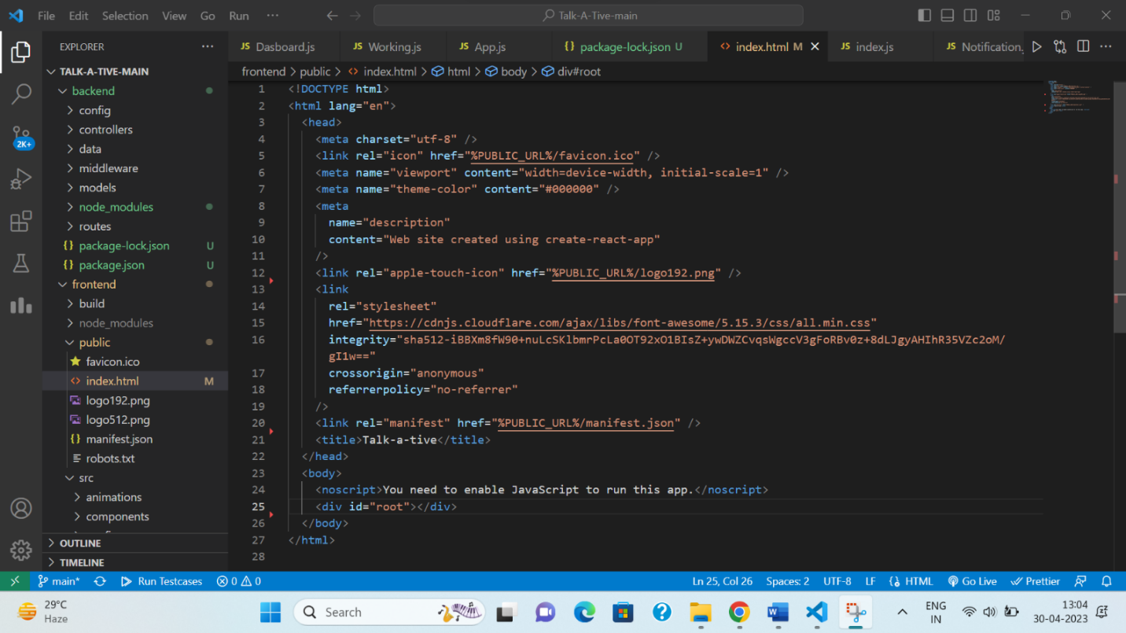

Fig. A.1- Index.html file

In fig A.1, the index.html file serves as the entry point for the entire application. When you run a React app, the index.html file is loaded into the browser and then the React code takes over from there.

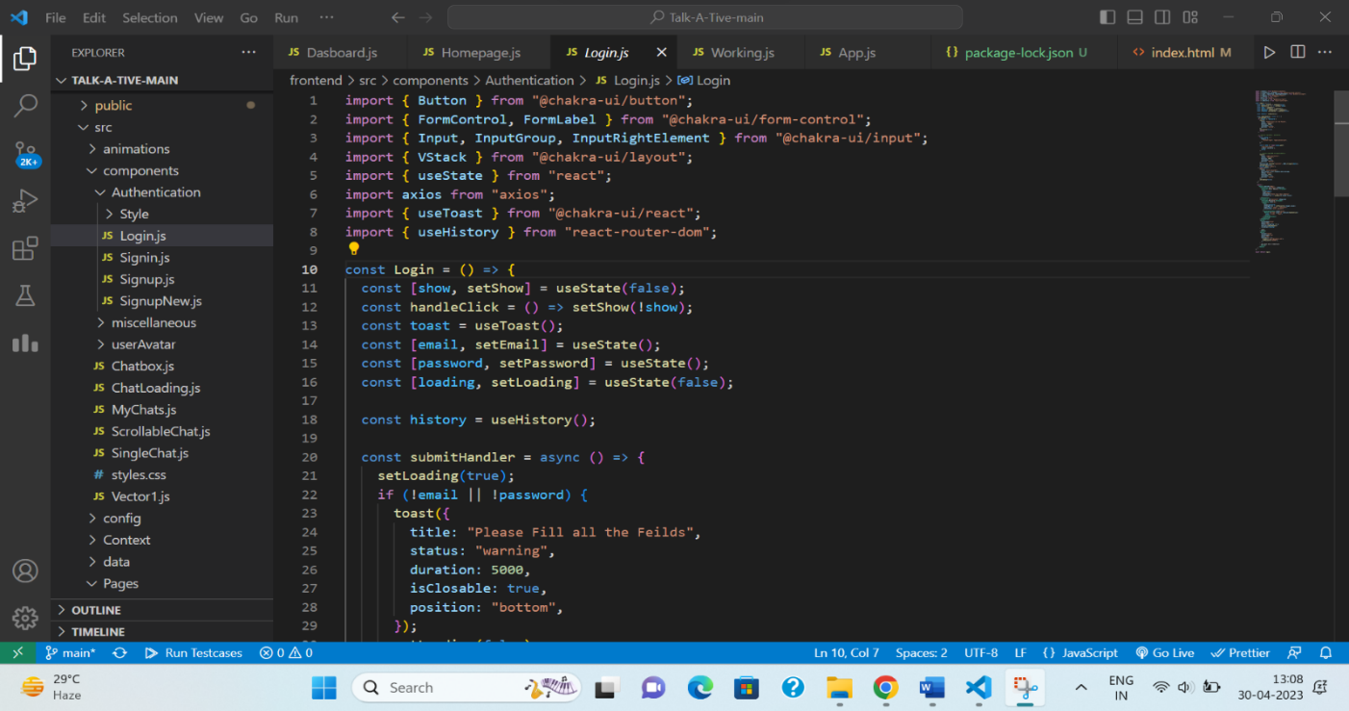

Fig. A.2 – Login Page component

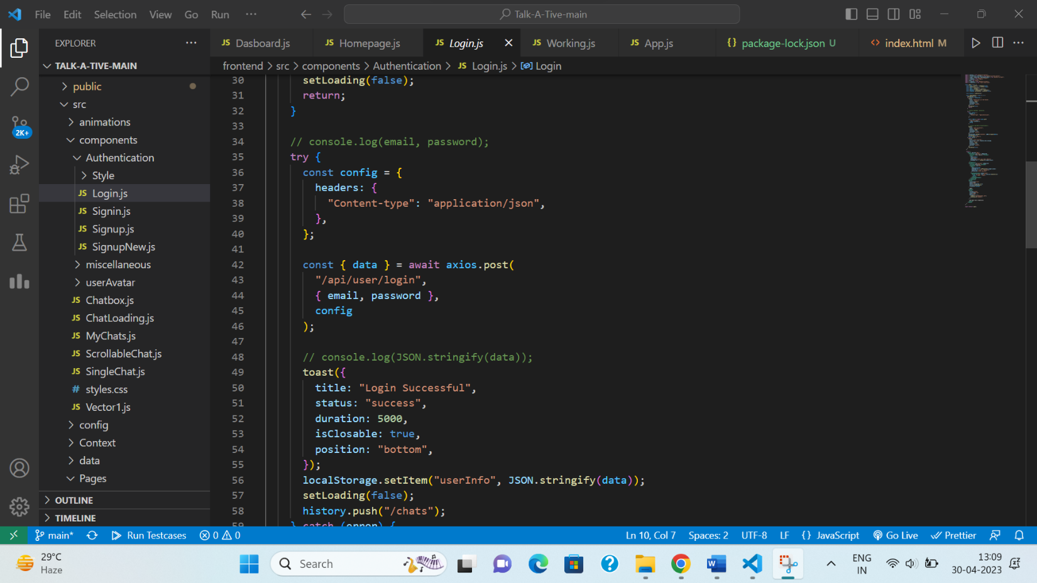

Fig. A.3 – Login Page component

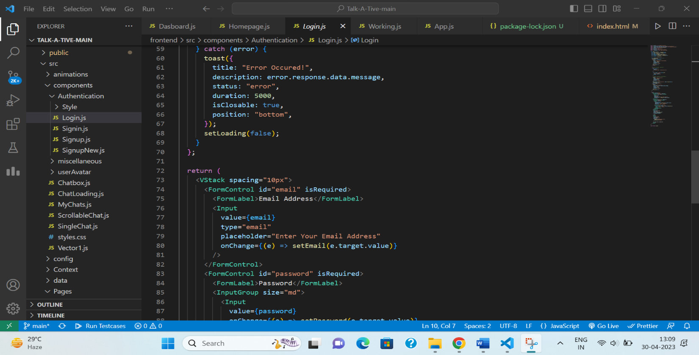

Fig. A.4 – Login Page component

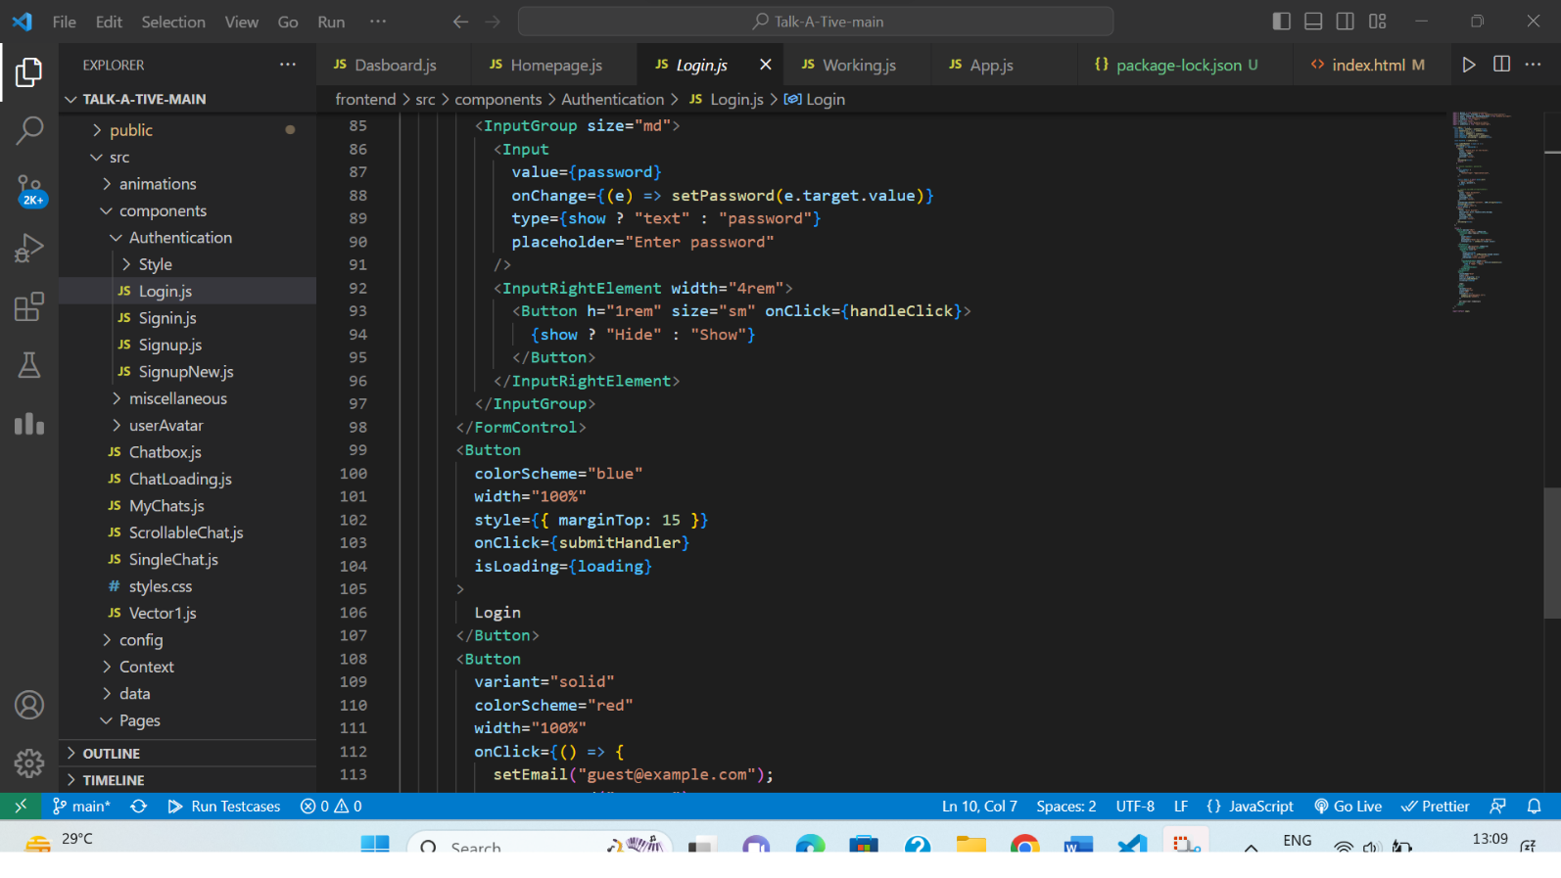

Fig. A.5 – Login Page component

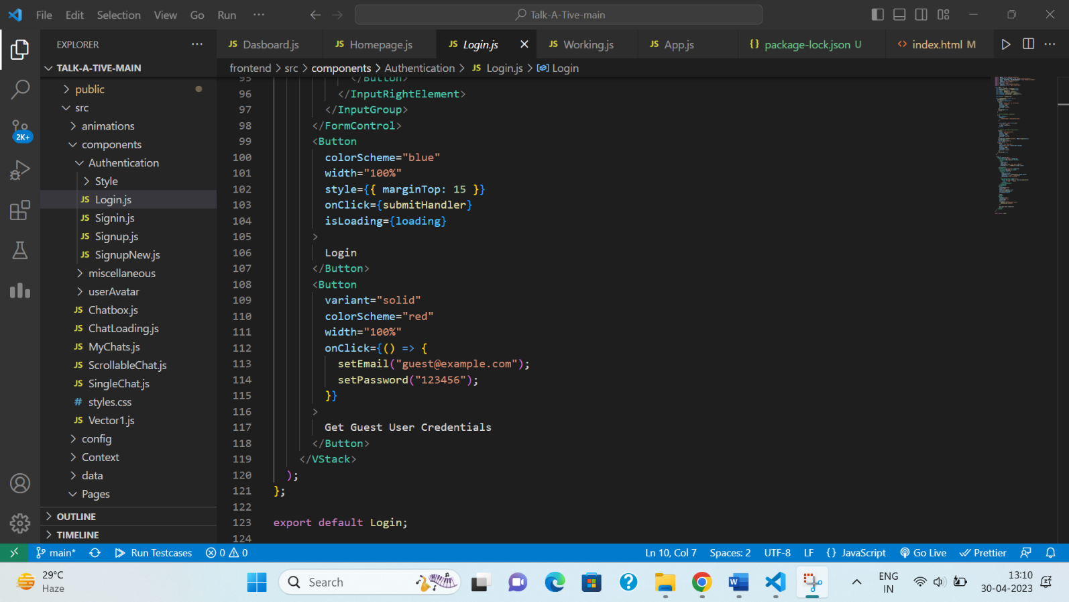

Fig. A.6 – Login Page component

Fig A.2 – Fig. A.6, shows the code for Login page component.

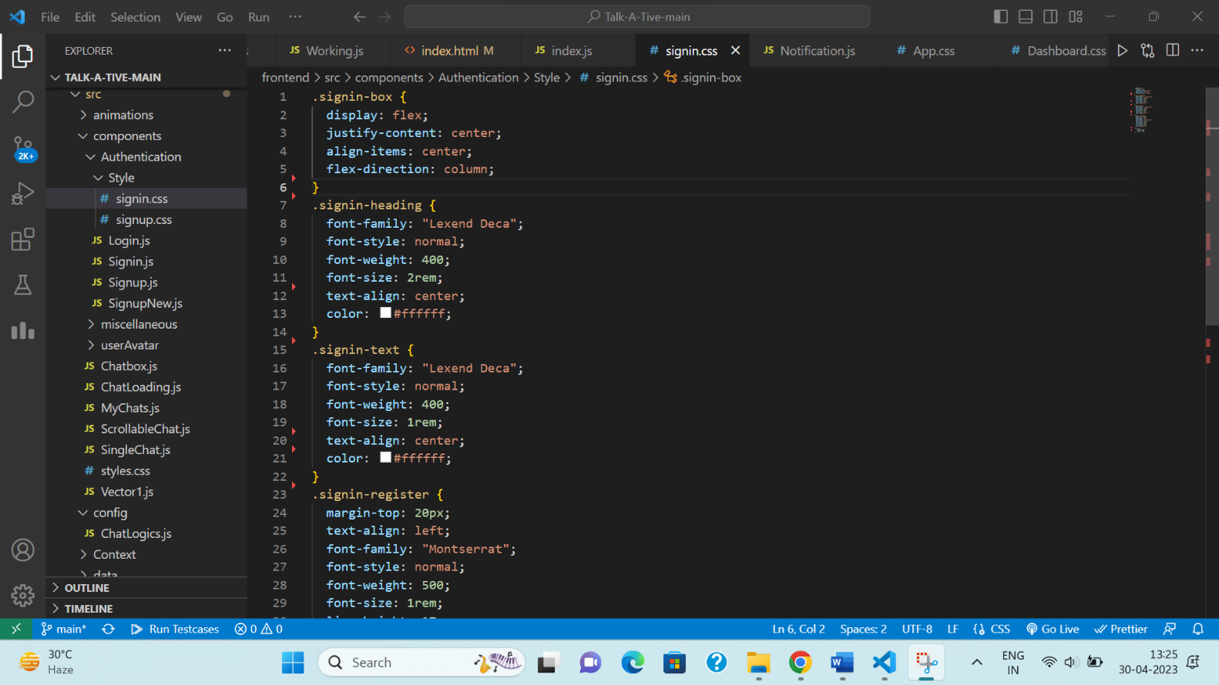

Fig. A.7 – Login Page CSS

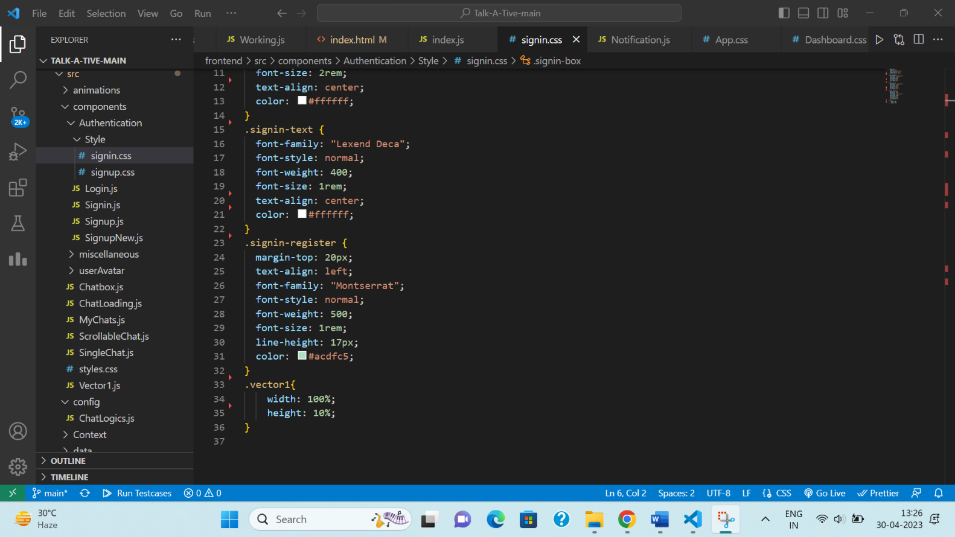

Fig. A.8 – Login Page CSS

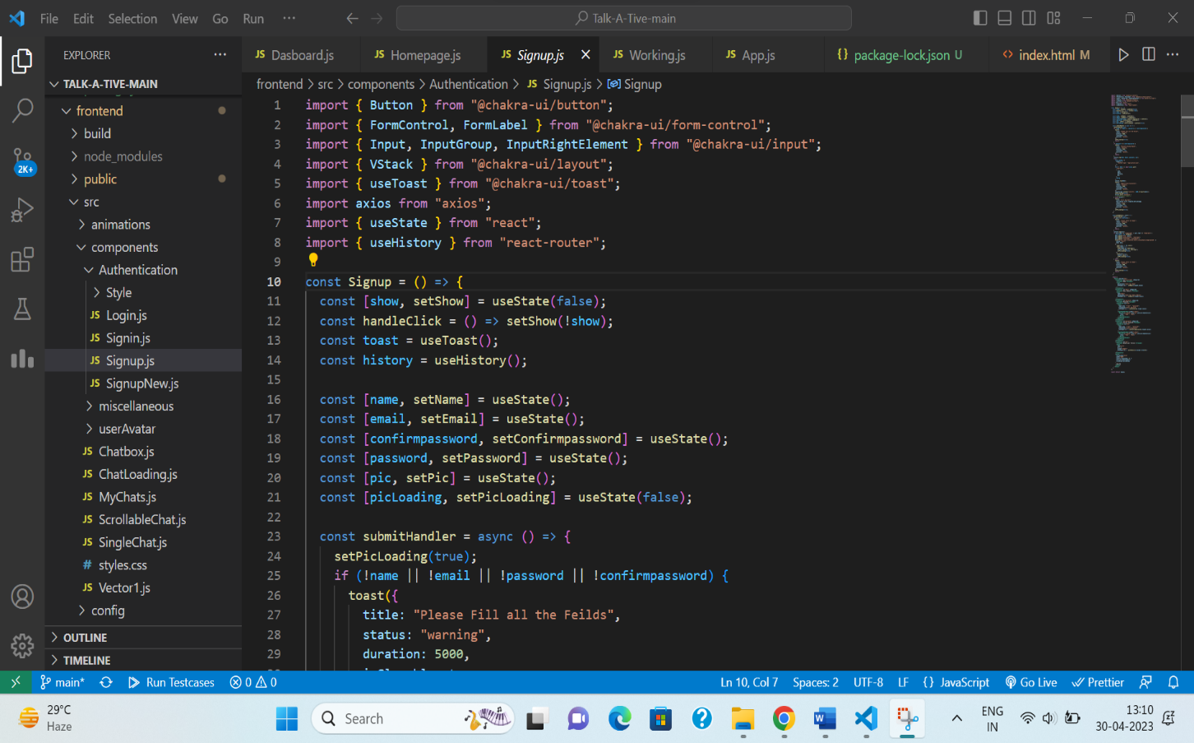Fig A.7 & Fig. A.8 shows the styling of login page.

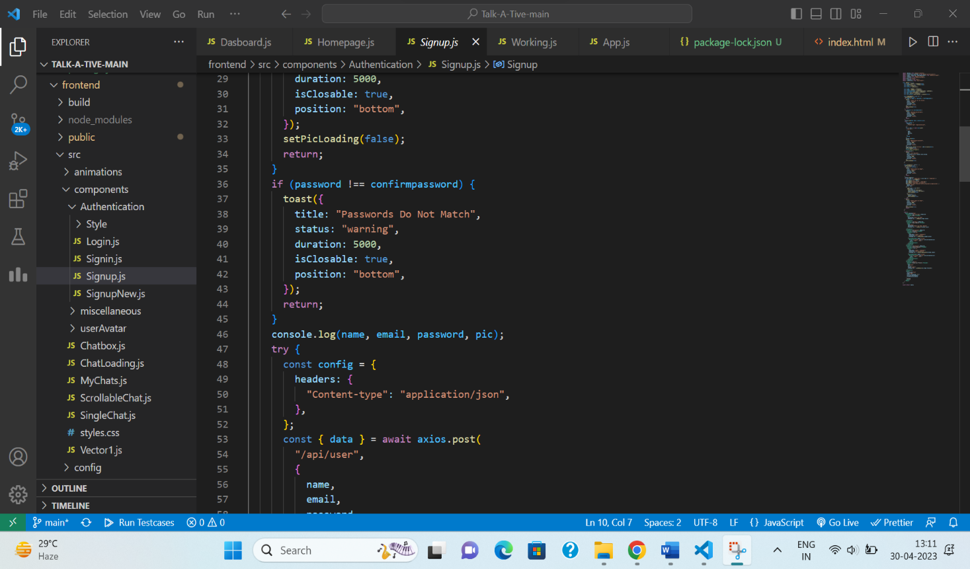Fig. A.9 – Sign Up Page Component

Fig. A.10 – Sign Up Page Component

Fig. A.11– Sign Up Page Component

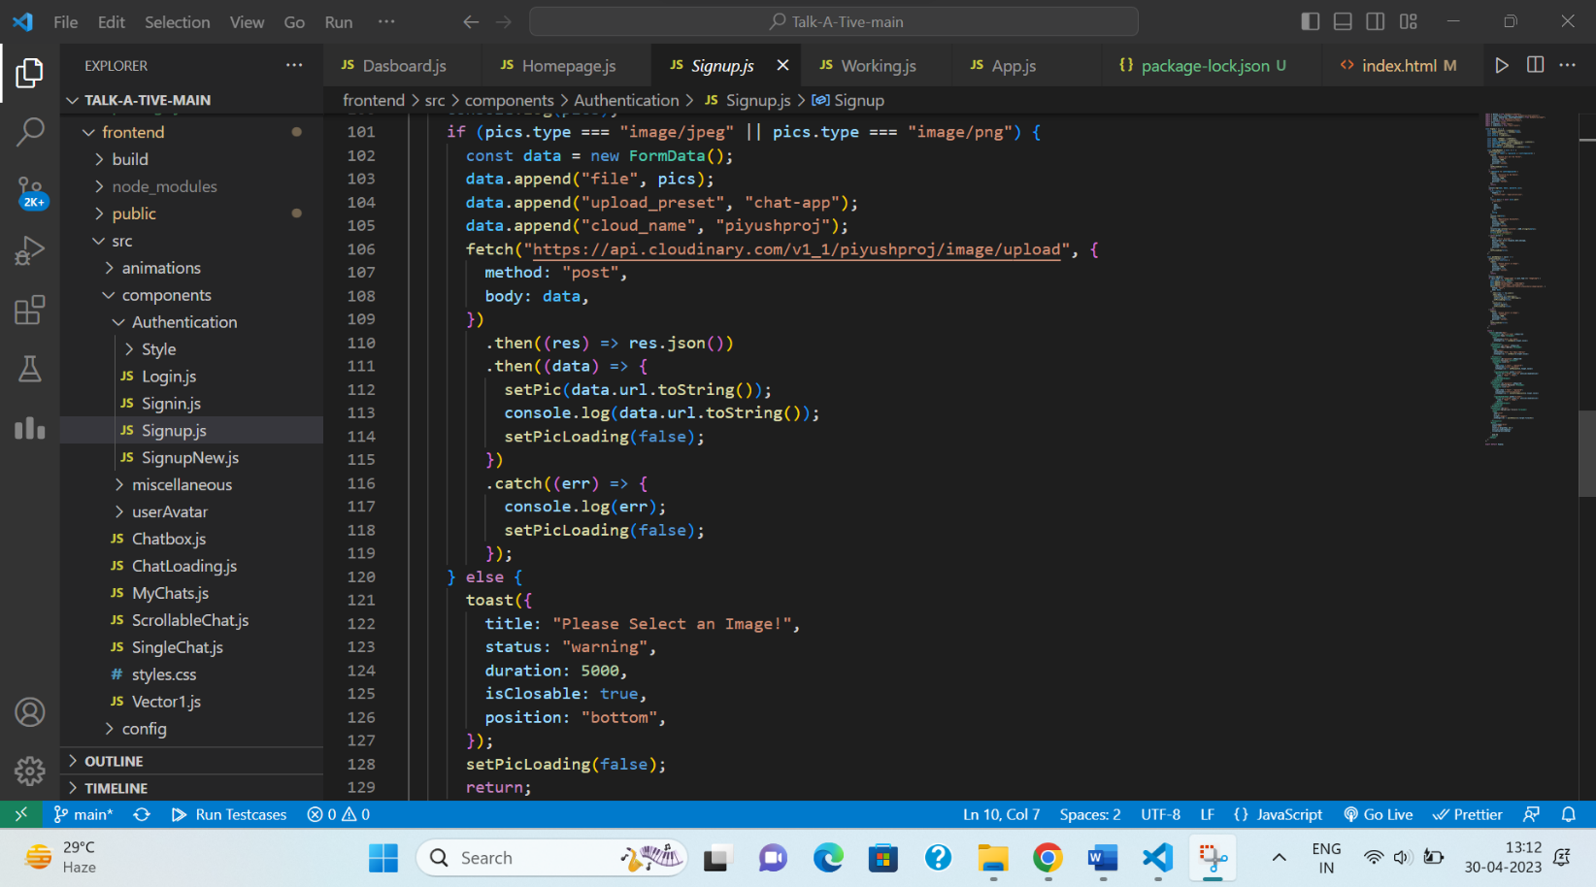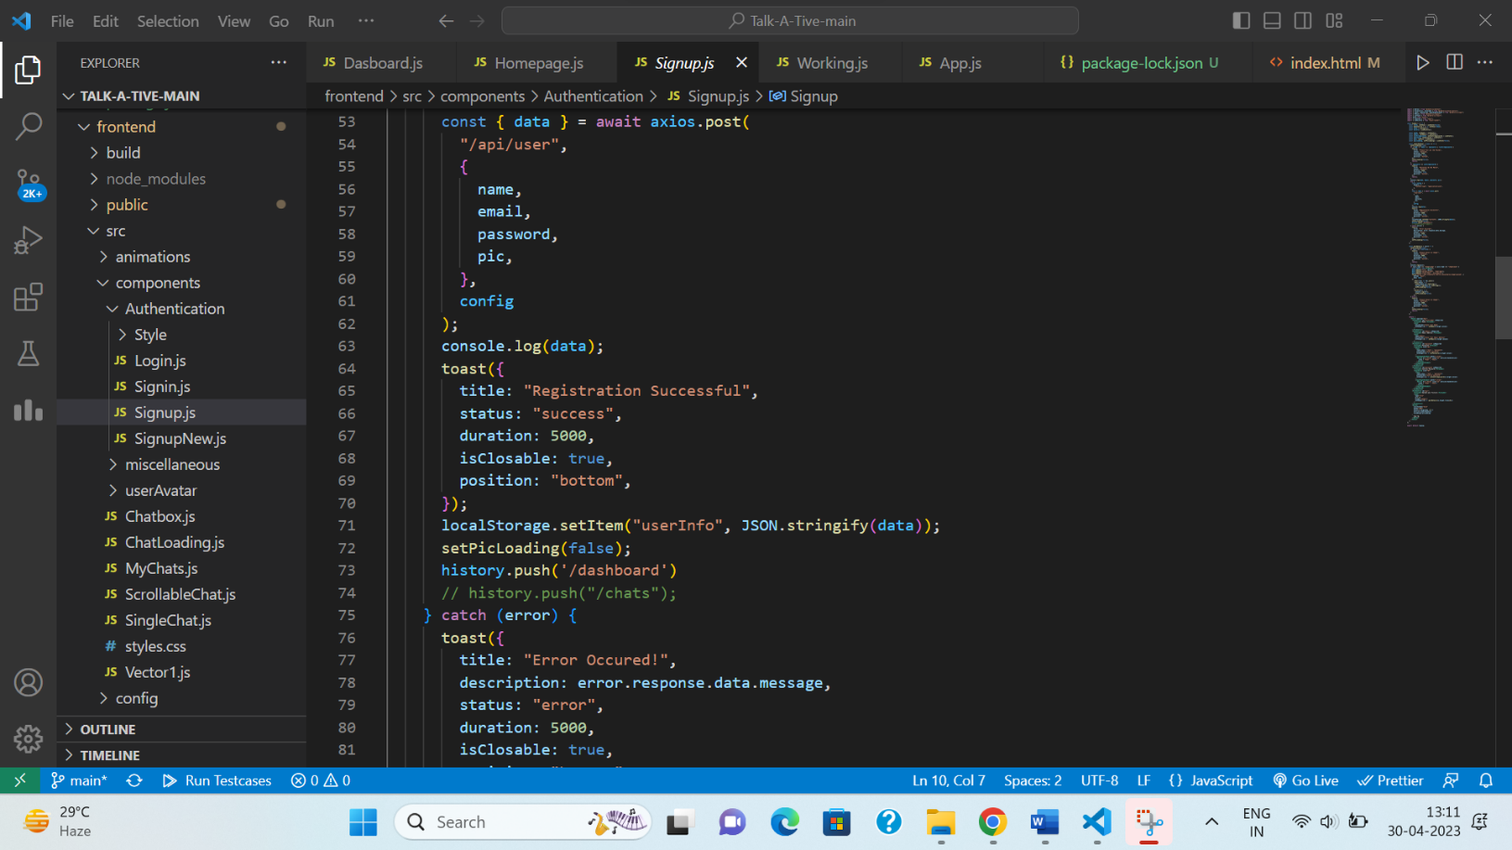

Fig. A.12 – Sign Up Page Component

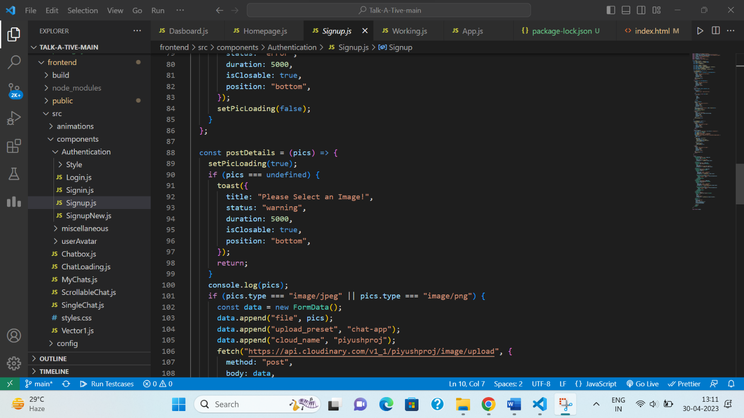Fig. A.13– Sign Up Page Component

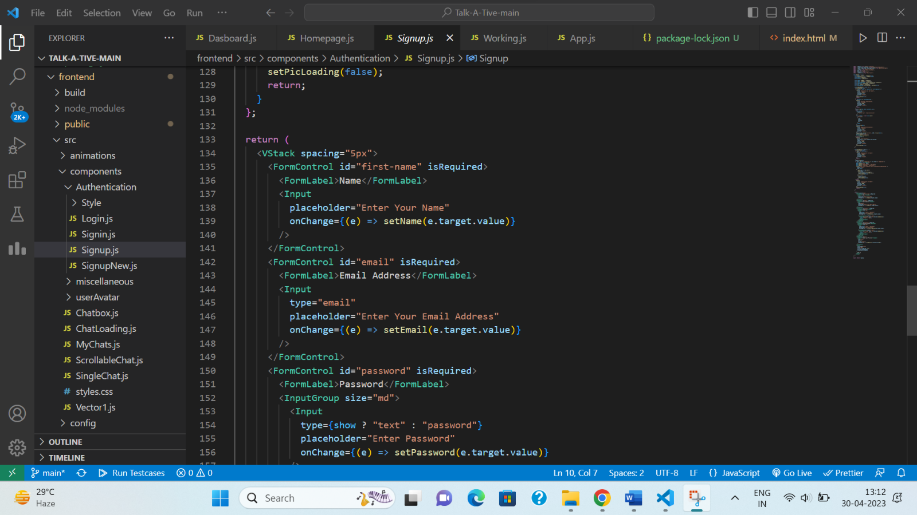

Fig. A.14– Sign Up Page Component

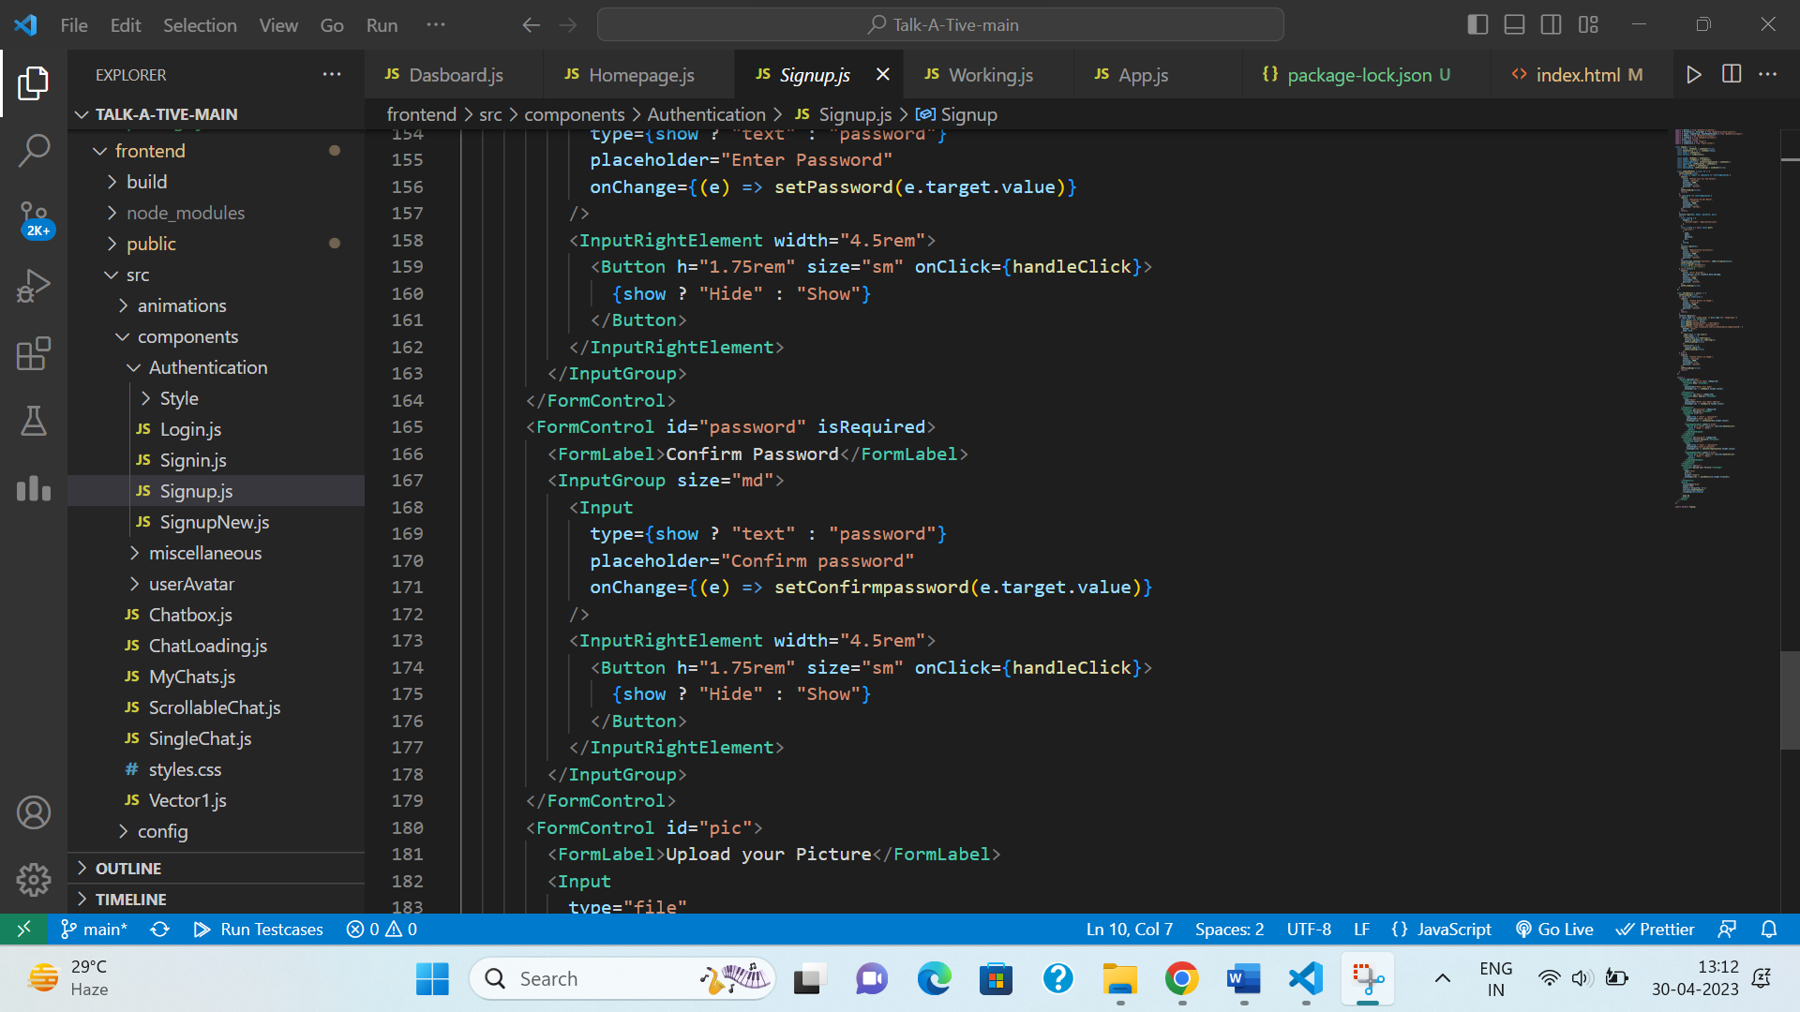

Fig. A.15 – Sign Up Page Component

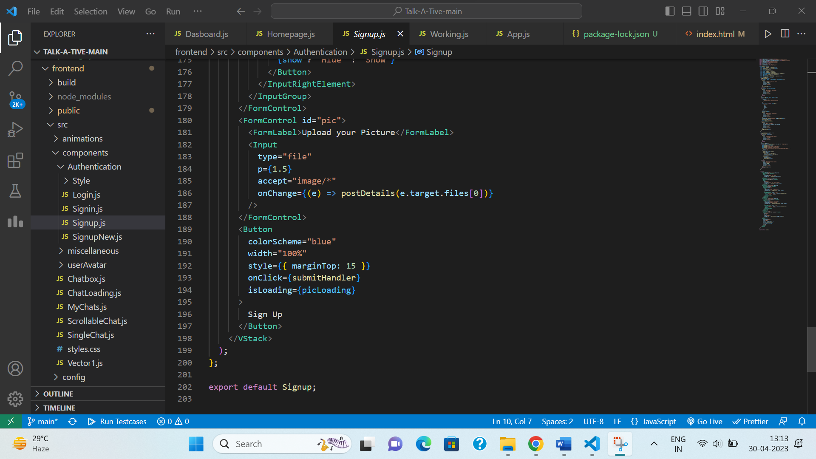

Fig. A.16 – Sign Up Page Component

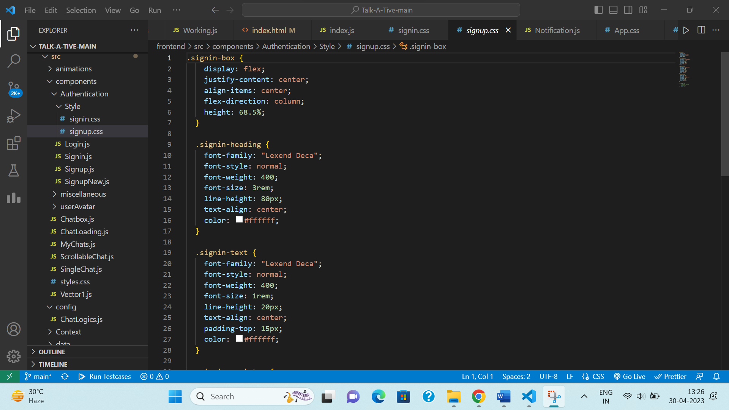Fig. A.9 – Fig. A.16 , shows us the code for sign up component.

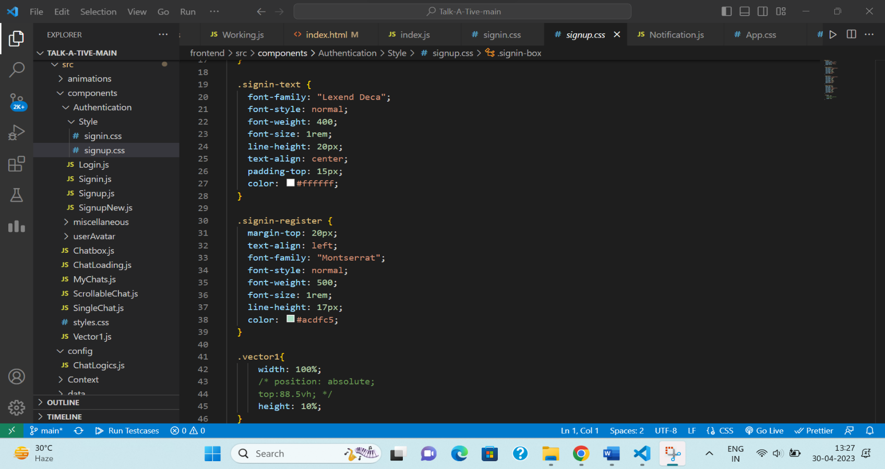Fig. A.17 – Sign Up Page CSS

Fig. A.18 – Sign Up Page CSS

Fig. A.17 & Fig. A.18 shows the code for Sign Up page styling.

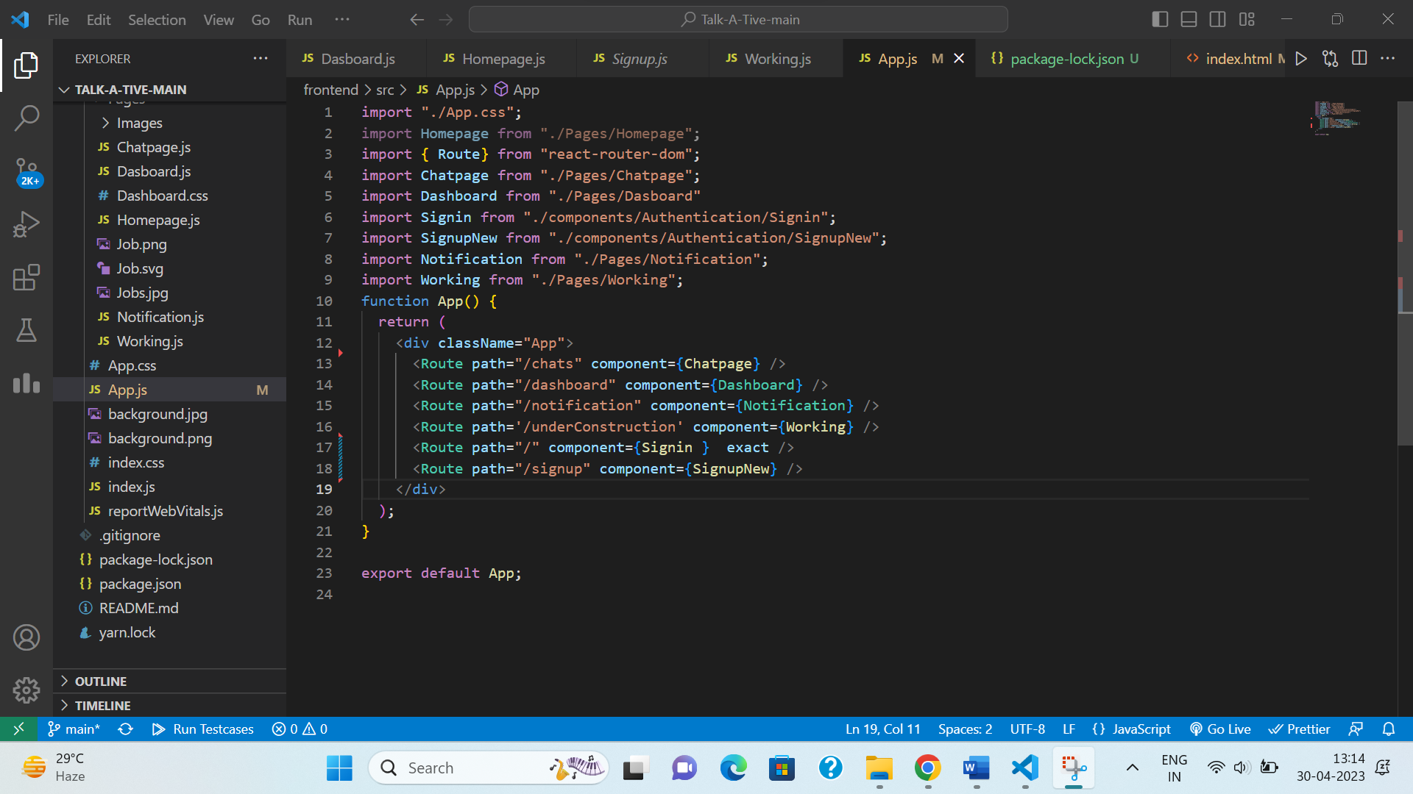

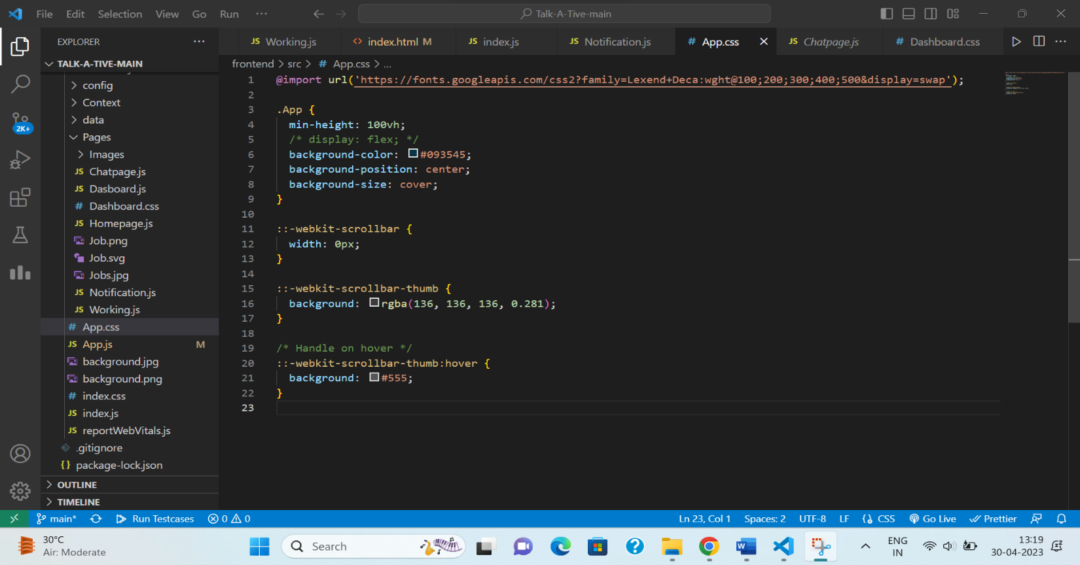Fig. A.19 – App.js

Fig. A.20 – App.CSS

Fig. A.19 shows App.js component which is typically the entry point for your application and serves as the top-level component. It is where you can define the overall layout of your application and render other components.

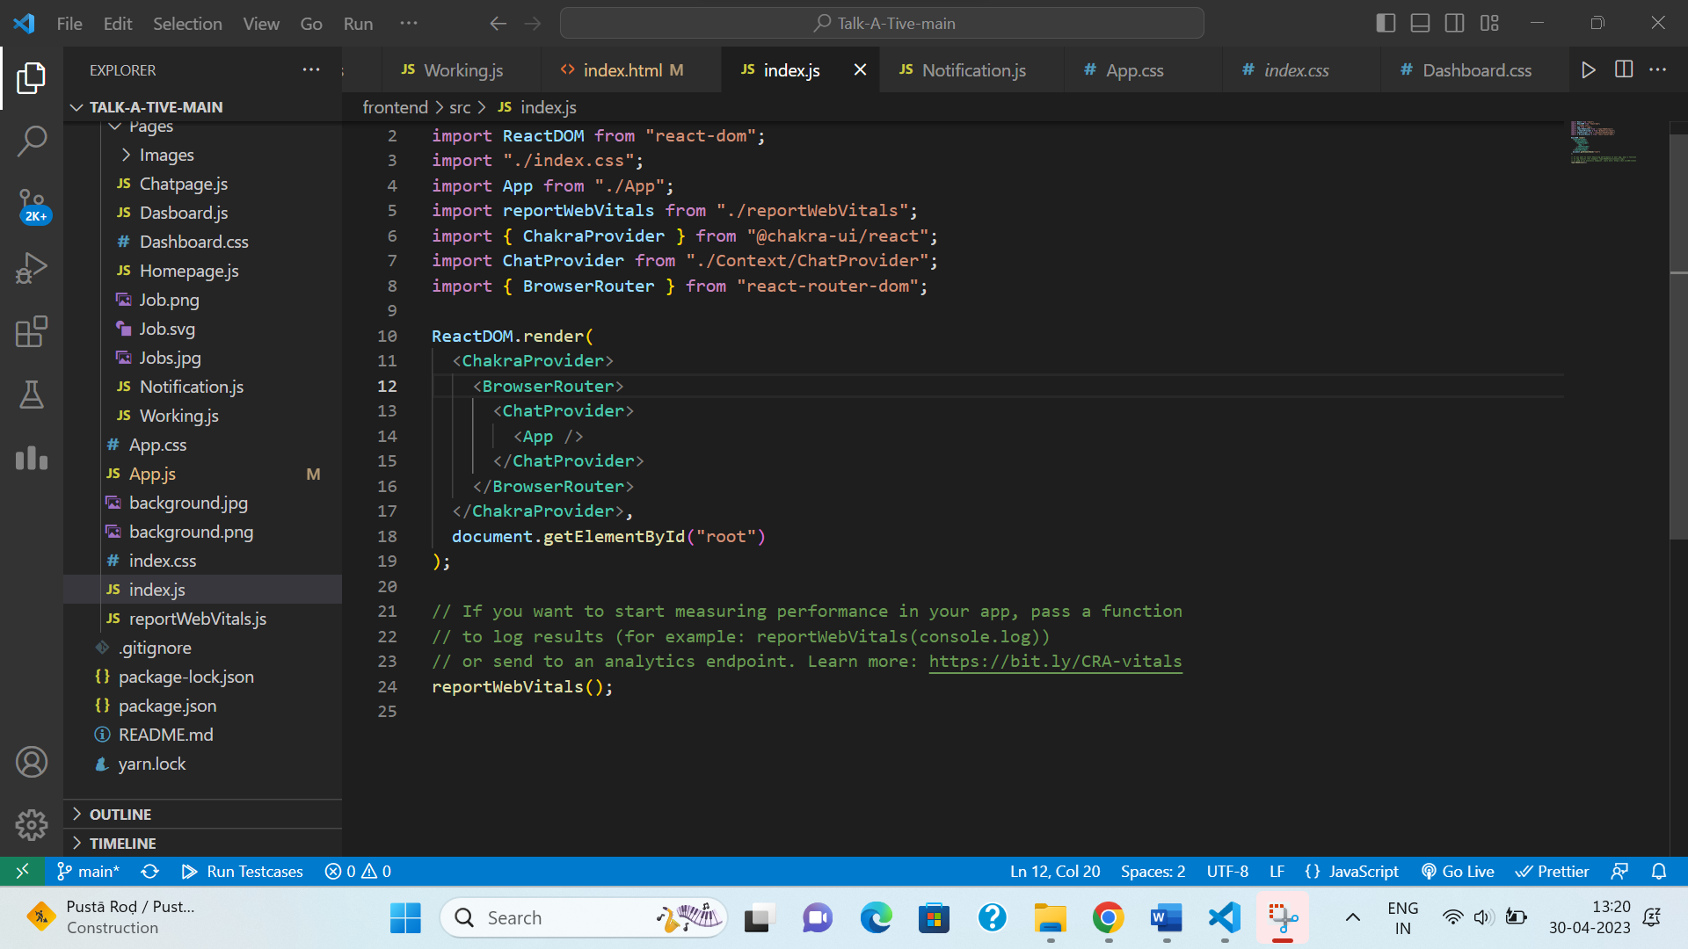

Fig. A.21 – Index.js

Fig. A.21 shows index.js component which is typically the entry point for your application's JavaScript code. It is where you can import the main App component and render it to the DOM.

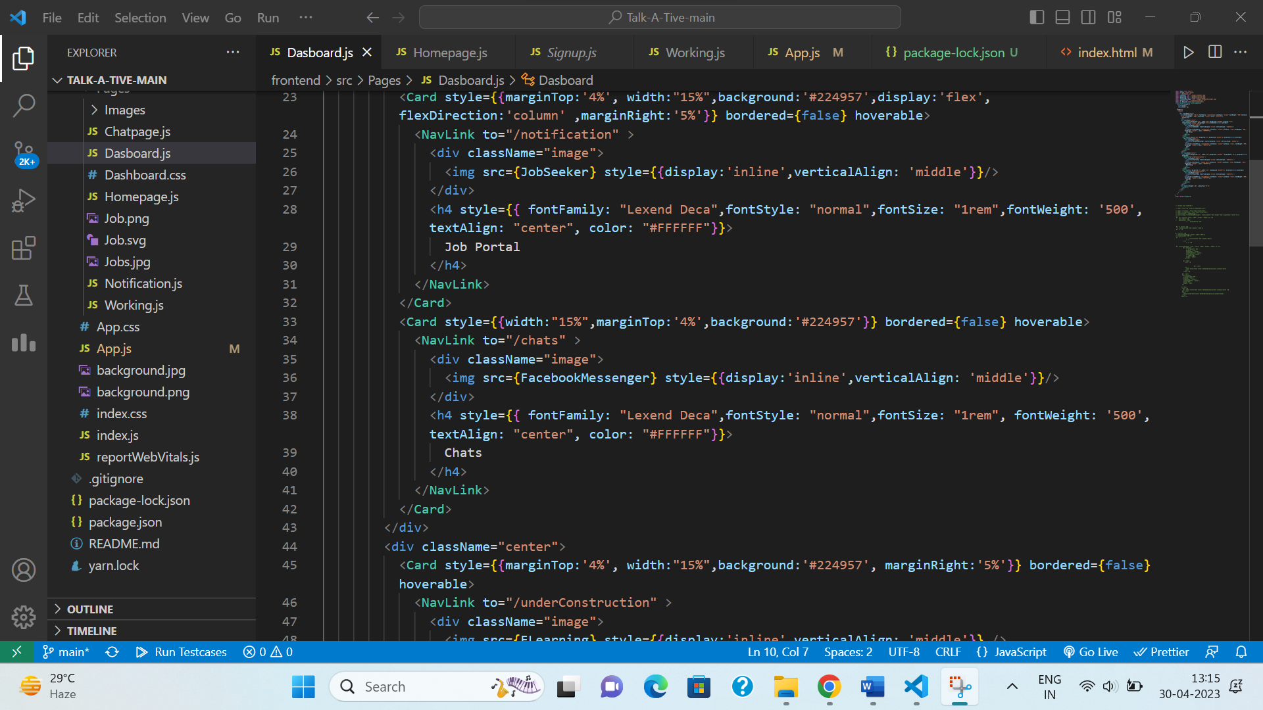Fig. A.22 – Dashboard Component

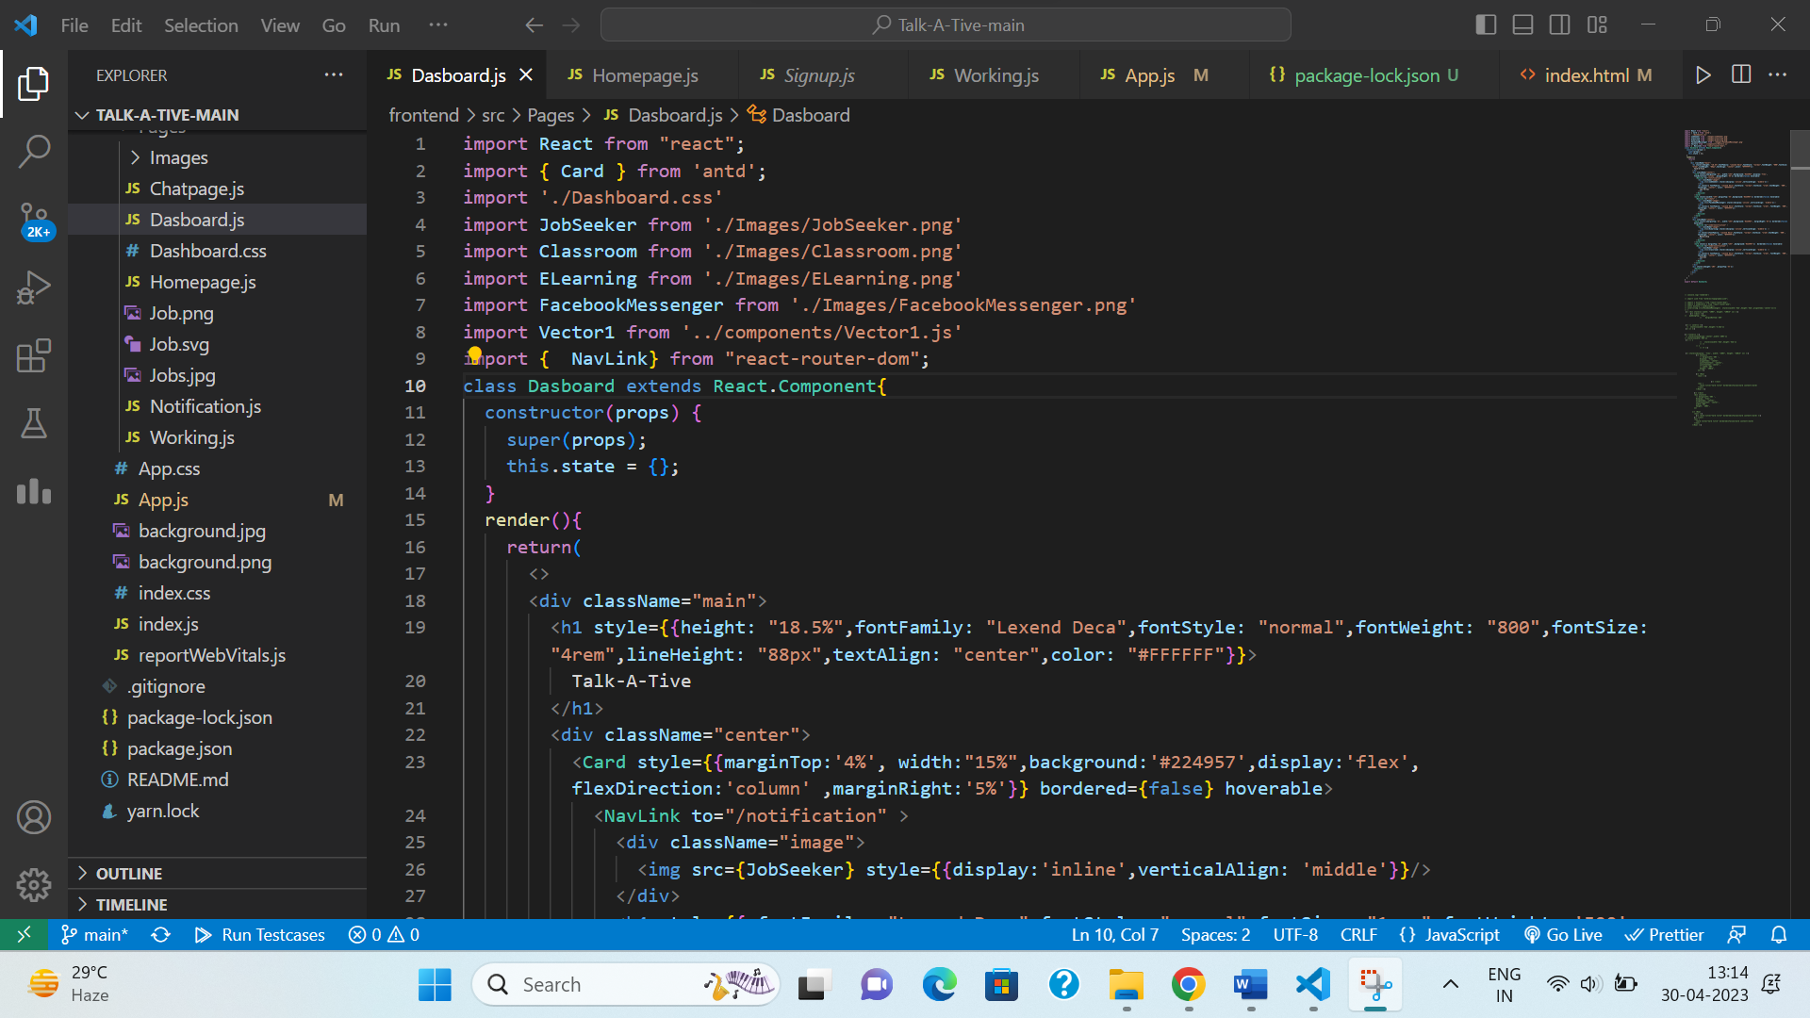

Fig. A.23 – Dashboard Component

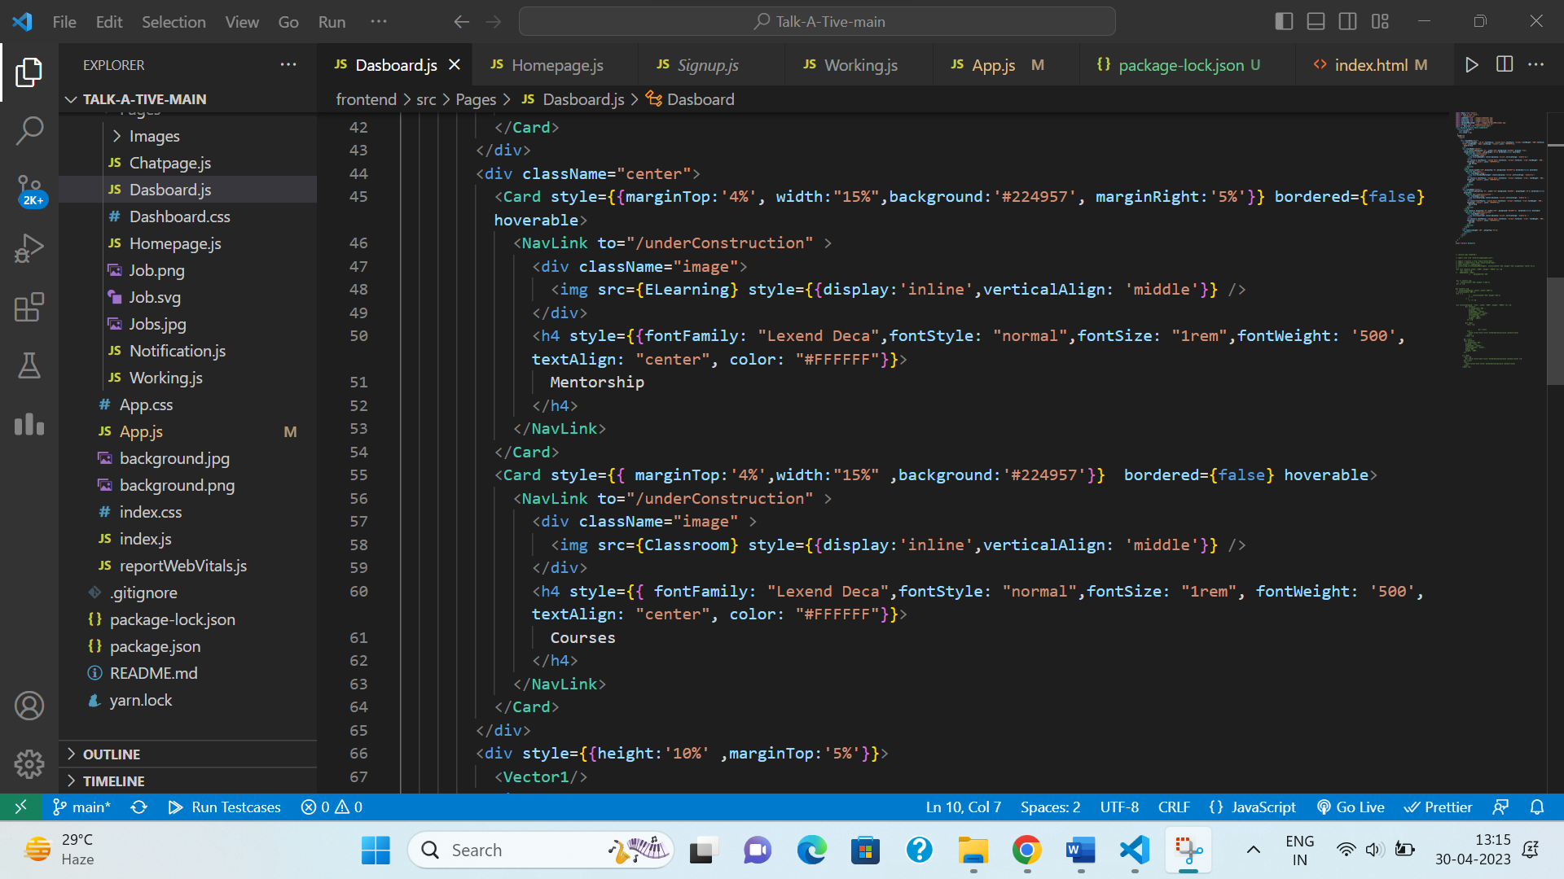

Fig. A.24 – Dashboard Component

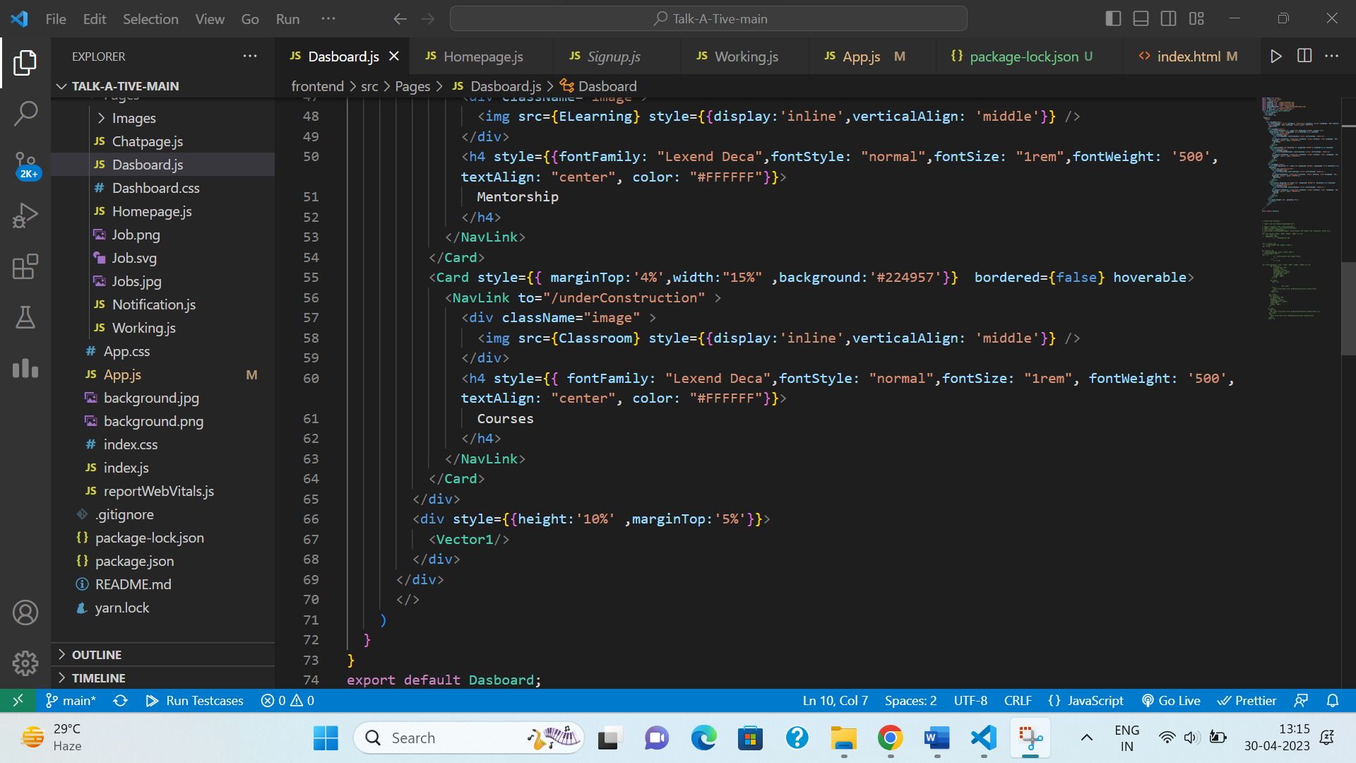

Fig. A.25 – Dashboard Component

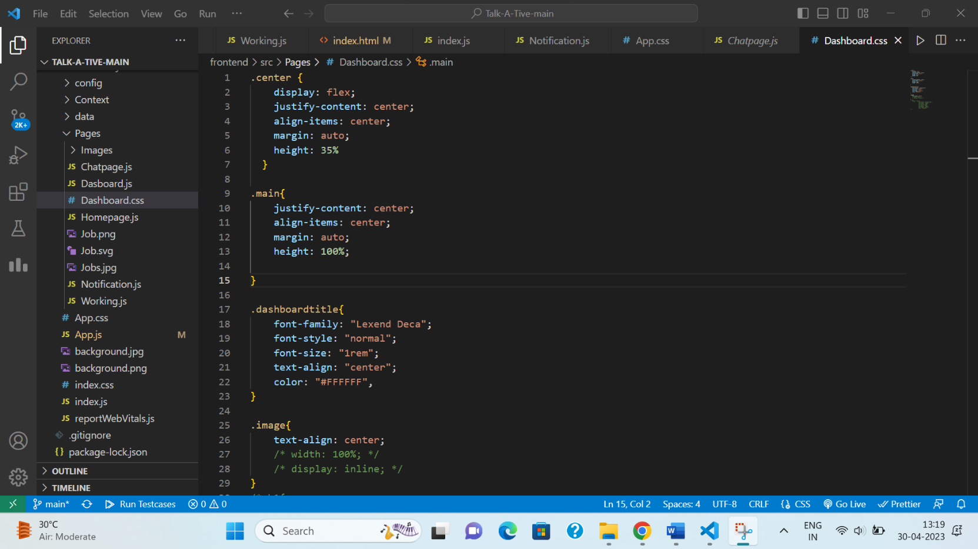

Fig. A.26 – Dashboard Component Styling

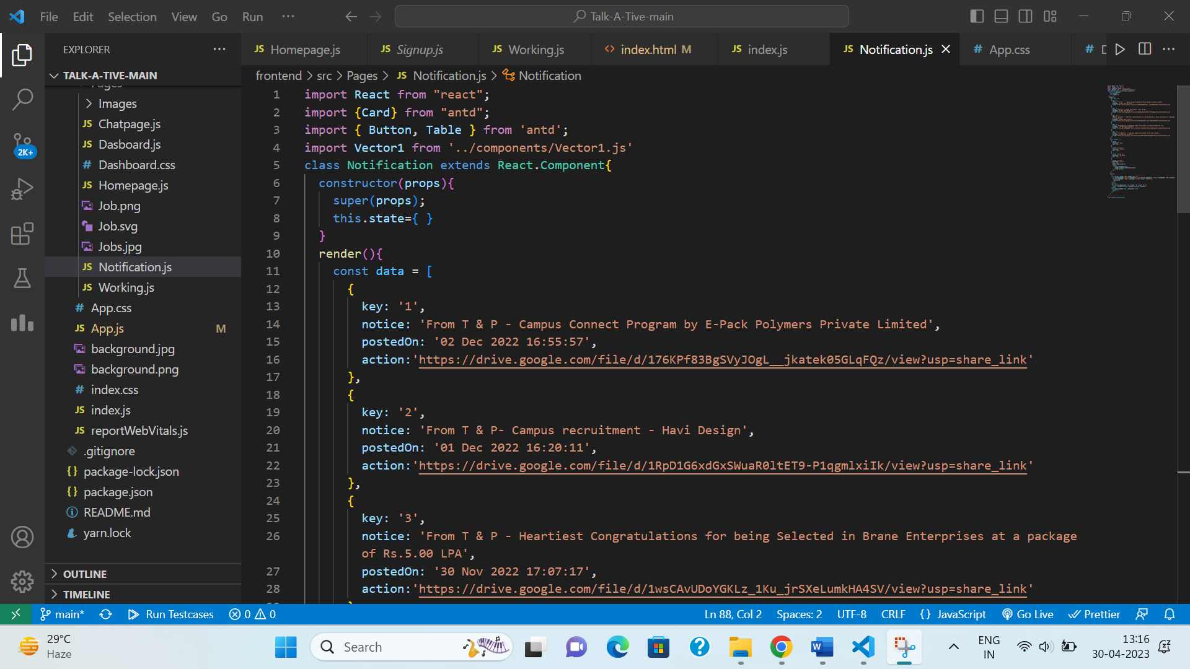Fig. A.22 – Fig. A.26 shows the code for dashboard component & its styling.

Fig. A.27 – Job Page Component

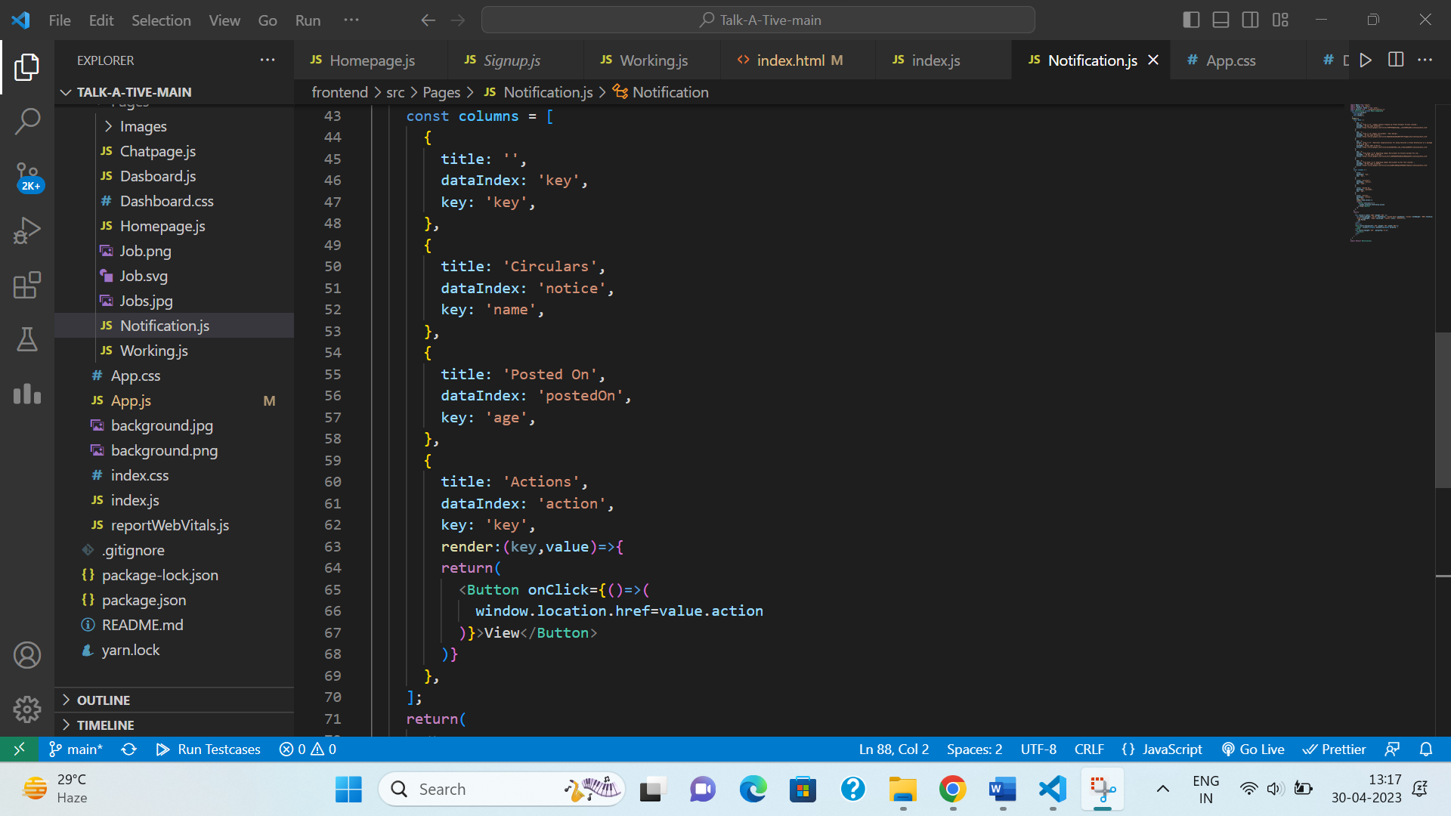Fig. A.28 – Job Page Component

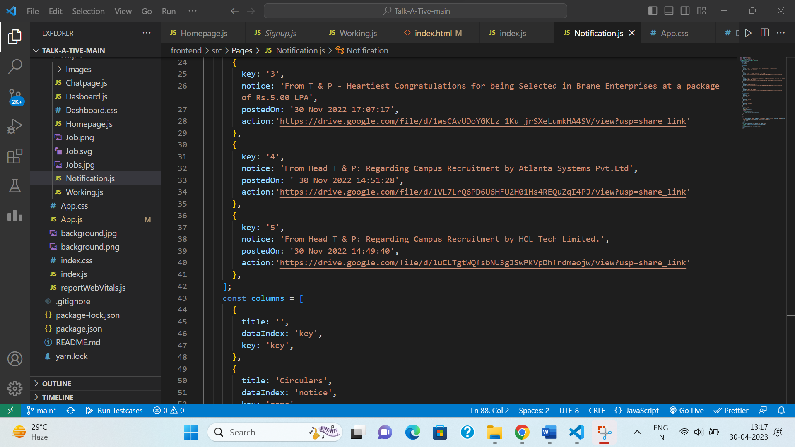

Fig. A.29 – Job Page Component

Fig. A.27 – Fig. A.29 shows the code for Job Page component.

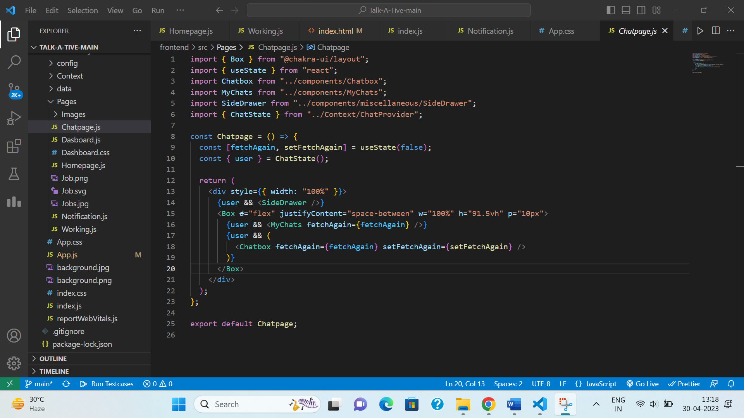

Fig. A.30 – Chat Page Frontend

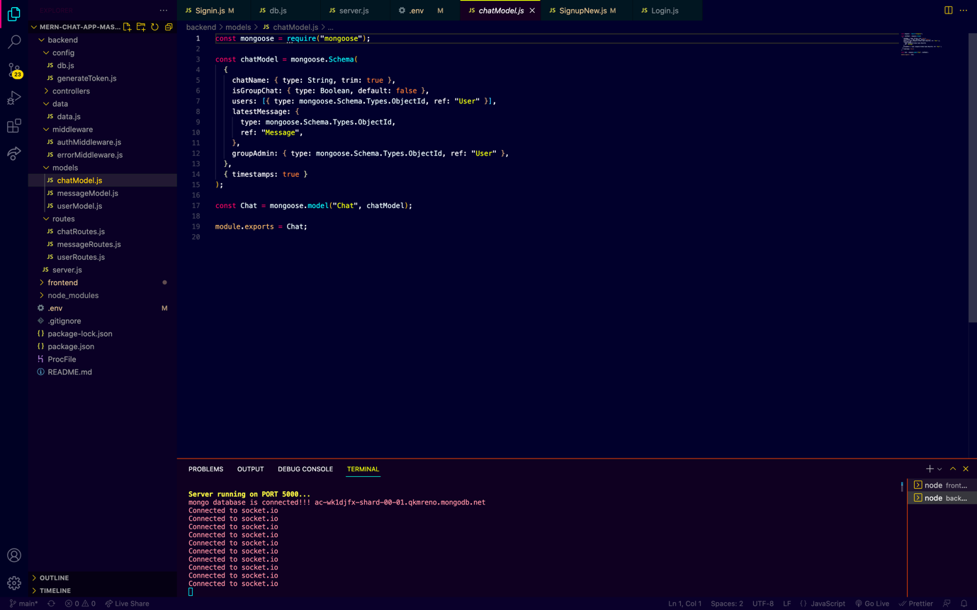Fig A.30 shows the code for chat page component

Fig. A.31 – Chat Backend Model

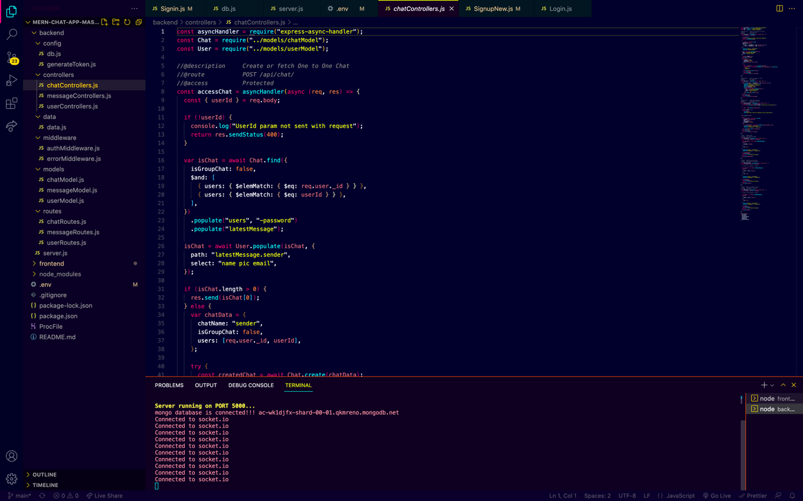

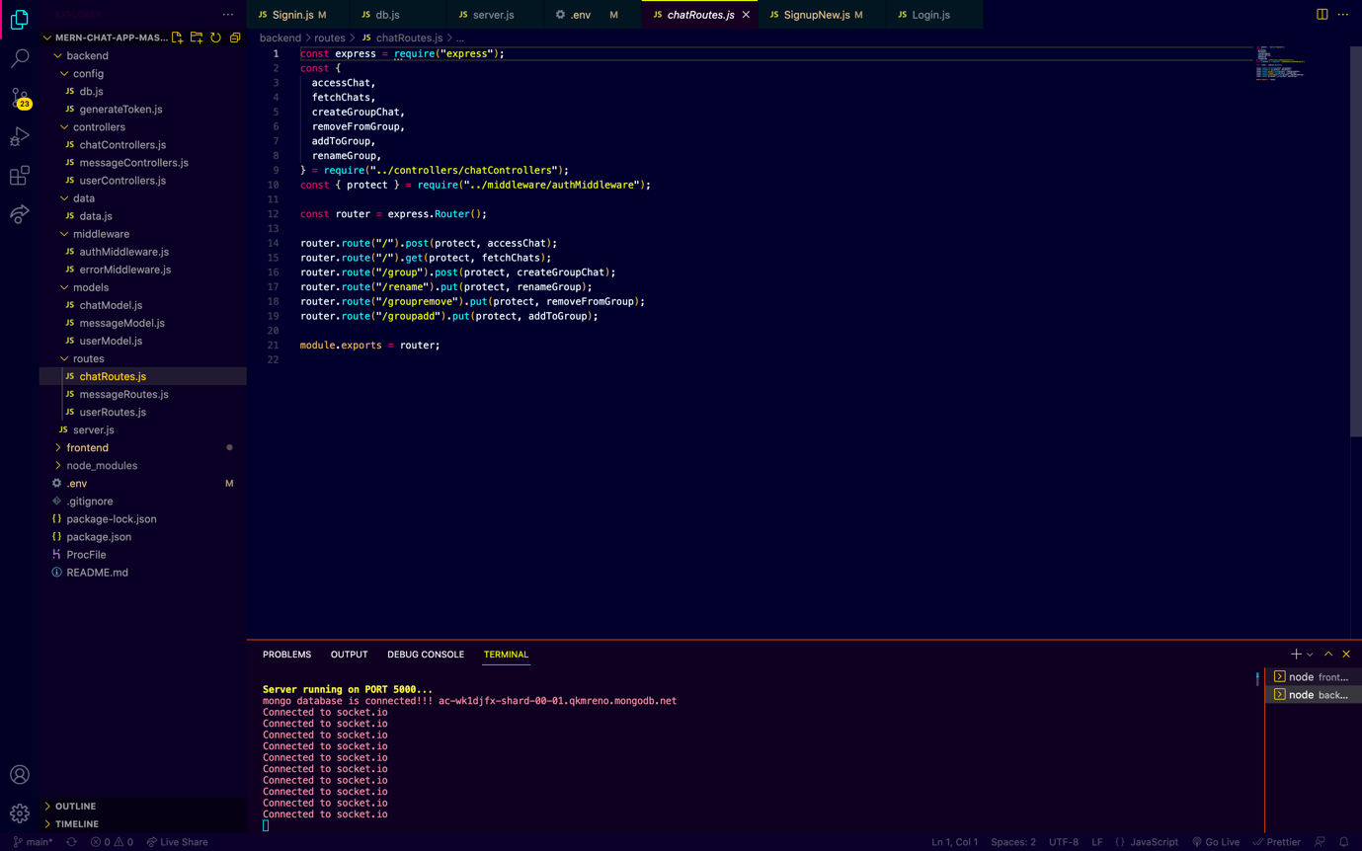Fig. A.32 – Chat Backend Controller

Fig. A.33– Chat Backend Routes

Fig. A.31 -Fig. A.33 shows the code for chat component backend, which consist of a model which creates a storage schema at MongooDB, a route which creates the http requests & a controller which controls the flow of message.

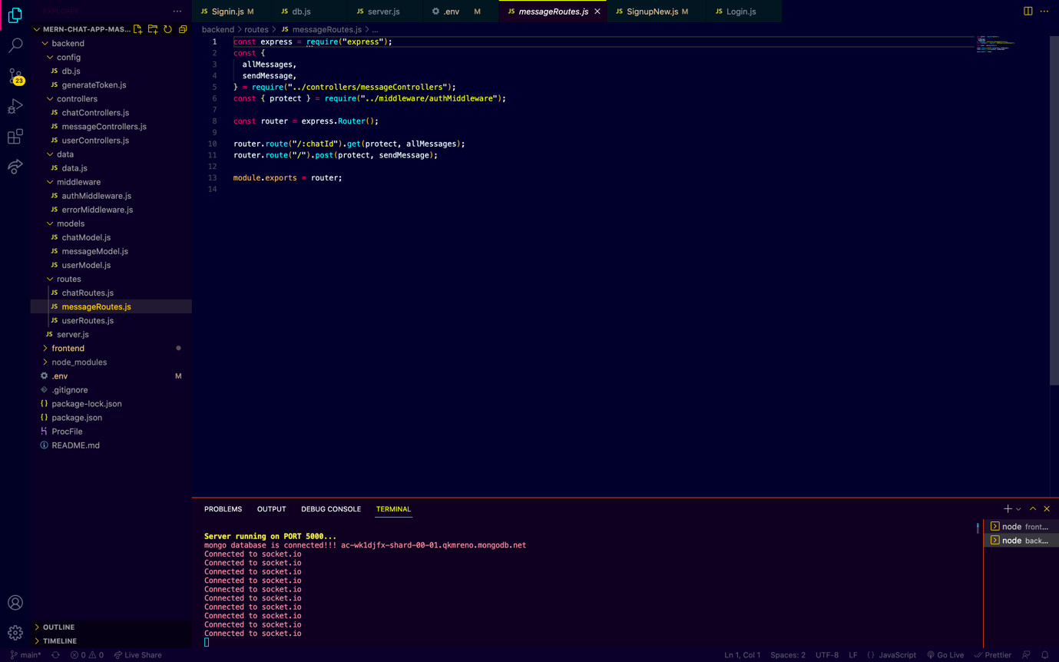

Fig. A.34– Message Backend Routes

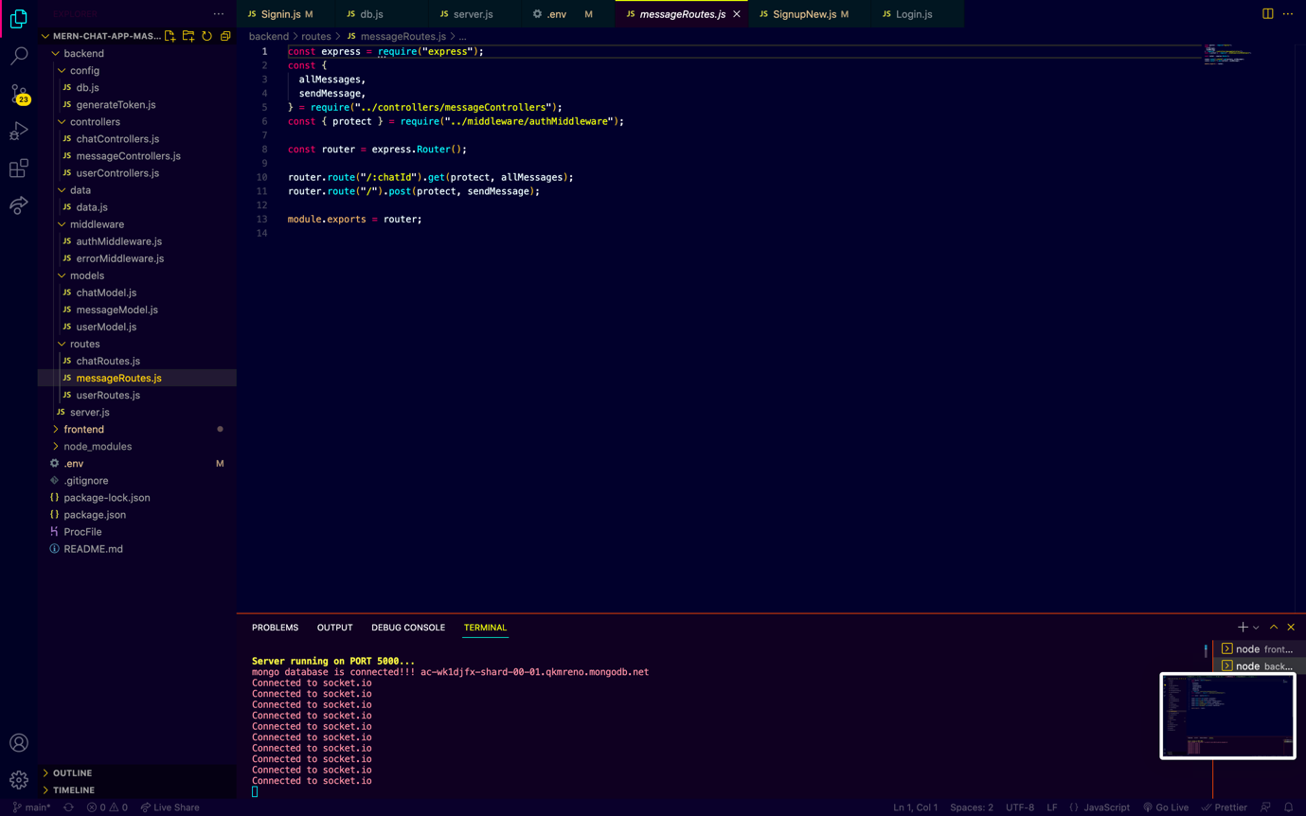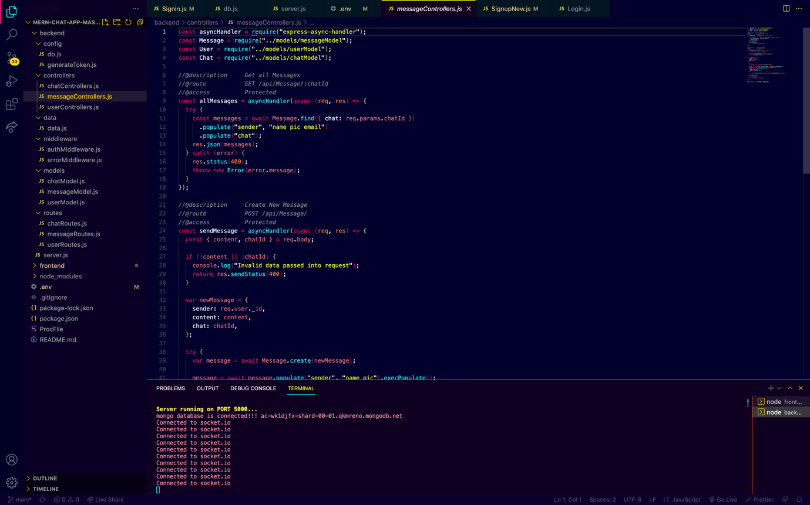Fig. A.35– Message Backend Controller

Fig. A.36– Message Backend Routes

Fig. A.34 -Fig. A.36 shows the code for message component backend, which consist of a model which creates a storage schema at MongooDB, a route which creates the http requests & a controller which controls the flow of message.

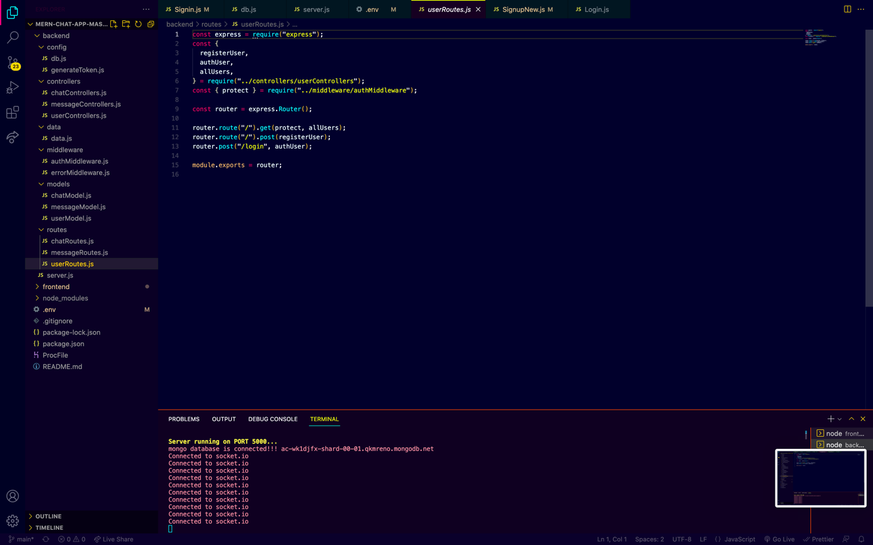

Fig. A.37– User Backend Routes

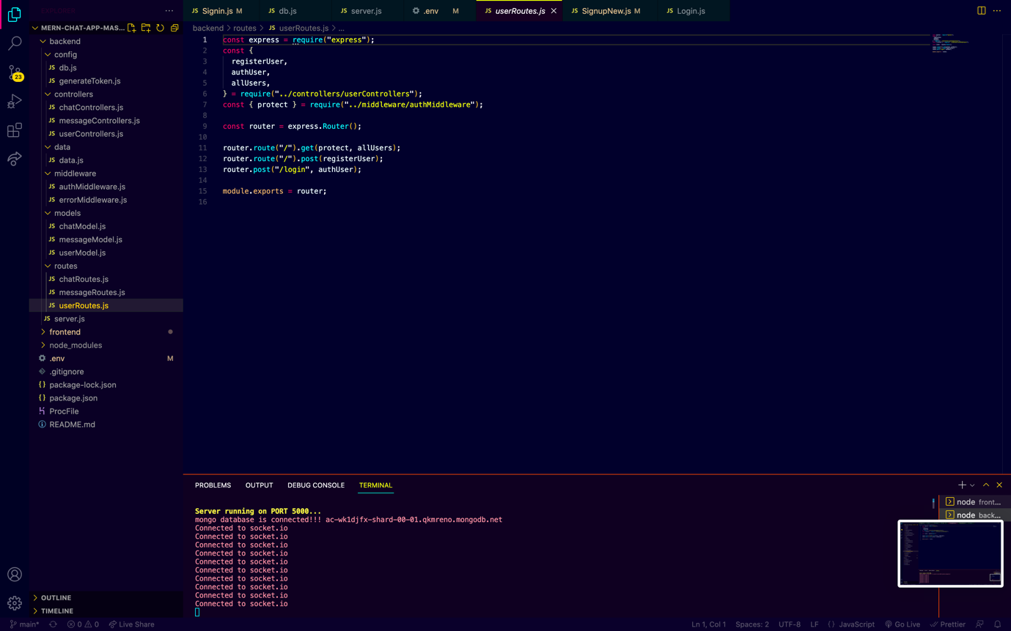Fig. A.38– User Backend Controller

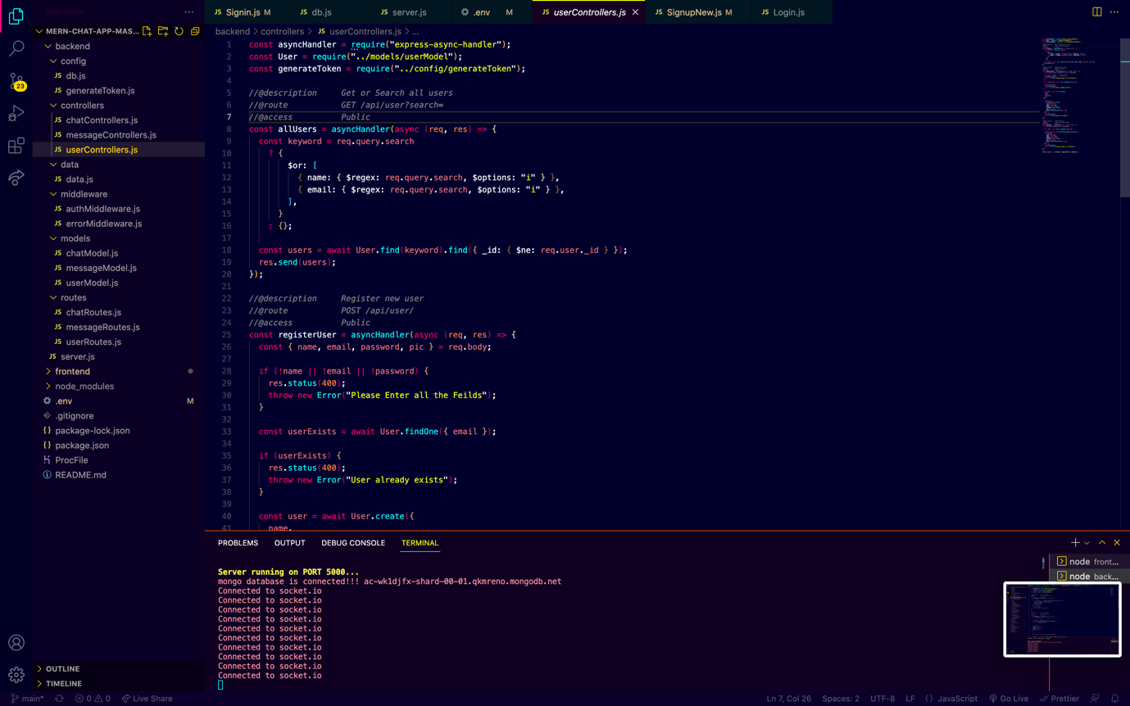

Fig. A.39– User Backend Model

Fig. A.37 -Fig. A.39 shows the code for user component backend, which consist of a model which creates a storage schema at MongooDB, a route which creates the http requests & a controller which controls the flow of user.

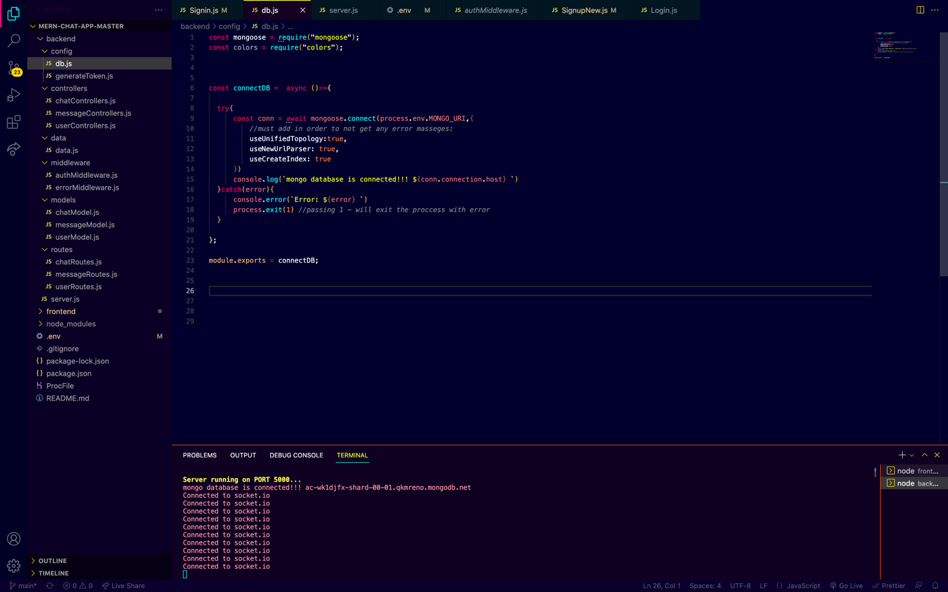

Fig. A.40– DB Config

Fig. A.40 shows the code to confid the DB with NodeJS

Fig. A.41– User Authentication

Fig. A.41 shows the code for user authentication

